IONIAN UNIVERSITY
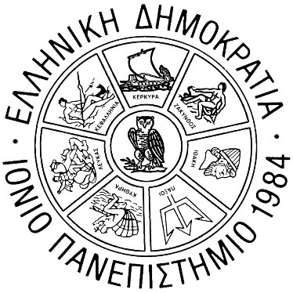
FACULTY OF INFORMATION SCIENCE & INFORMATICS
DEPARTMENT OF ARCHIVES, LIBRARY SCIENCE
AND MUSEOLOGY

Master of Science in
« Digital Information Management - Information Services »

MASTER'S THESIS
« Extending RiC-CM to capture digital preservation purposes »

Evangelia Thanou

Corfu July, 2026

This page is intentionally blank

IONIAN UNIVERSITY
FACULTY OF INFORMATION SCIENCE & INFORMATICS
DEPARTMENT OF ARCHIVES, LIBRARY SCIENCE AND MUSEOLOGY

Master of Science in
«Digital Information Management - Information Services»

MASTER'S THESIS
« Extending RiC-CM to capture digital preservation purposes »
Evangelia Thanou
Student ID: alm.dimis2405

Supervisor:
Matthaios Damigos, Department of Archives, Library Science and Museology, Assistant Professor
Master's Thesis Examining Committee:
Manolis Gergatsoulis, Department of Archives, Library Science and Museology, Professor
Eleftherios Kalogeros, Department of Archives, Library Science and Museology, Laboratory Teaching Staff

Corfu July, 2026

AUTHOR’S DECLARATION:
I explicitly declare that, in accordance with Article 8 of the Greek Law 1599/1986, and Articles 2, 4, and 6, paragraph 3 of the Greek Law 1256/1982, the present work is exclusively the result of my personal effort and does not infringe on any form of third-party intellectual property rights. It is not a product of partial or complete plagiarism, and the sources used are limited solely to the bibliographical references.
Author’s signature: …………………
This Thesis and its results are the joint property of the Ionian University and the author. Each of these two parties has the right to independently use, reproduce and redistribute the thesis and/or its results (in whole or in part) for educational and research purposes, always citing the title and author of the Thesis, together with the name of the Ionian University where the Thesis has been presented and examined.
Acknowledgements / Dedication
I would like to express my sincere appreciation to my thesis supervisor Matthaios Damigos, for his academic guidance, continuous support and feedback through this research for my master thesis. I would like to thank my family, my partner and my close friends for their support, understanding and encouragement through my master’s studies. Their patience and belief in me gave me the strength to overcome all the challenges and complete my studies. This master thesis is dedicated to all those who supported and believed in me and stood by my side during this academic journey.

This page is intentionally blank

Abstract
This thesis explores whether the Records in Contexts Conceptual Model (RiC-CM) and Ontology (RiC-O) can be extended to meet the needs of digital preservation. Contemporary digital artifacts are becoming increasingly complex, making a combined approach between archival description and preservation metadata essential. In this context, a comparative analysis is conducted between RiC-CM/RiC-O and the PREMIS standard, which is currently considered the foundational model for digital preservation management metadata. The aim of the research is to examine the extent to which RiC-O supports concepts and processes related to the long-term preservation of digital objects and to highlight the conceptual gaps that exist in relation to PREMIS. The methodology is based on a systematic process of collecting and mapping entities, properties, and relationships, which identifies both the similarities and differences between the two models, utilizing semantic technologies such as RDF and OWL. The results show that, while certain entities align directly, critical concepts such as integrity, dependencies, or storage conditions are not adequately covered by RiC-CM and RiC-O. Furthermore, PREMIS focuses primarily on technical documentation and preservation procedures, while RiC-CM emphasizes the representation of archival contexts and relationships between entities. Taking these findings into account, an extension of RiC-O is proposed that incorporates key concepts of digital preservation without altering its basic structure. This effort brings archival description and digital preservation closer together, offering a unified and extensible model that enhances interoperability and the long-term management of digital records. In conclusion, the research highlights the importance of semantic linking between archival and preservation data, which helps cultural and archival organizations create digital preservation systems that are more reliable and sustainable.
Keywords
RiC-CM, Conceptual Models, Digital Preservation, PREMIS, Mapping

This page is intentionally blank

Title and Abstract of the Thesis in Greek

«Εννοιολογική επέκταση του RiC-CM για την κάλυψη αναγκών ψηφιακής διατήρησης»

Περίληψη
Η παρούσα διατριβή διερευνά κατά πόσον το εννοιολογικό μοντέλο «Records in Contexts» (RiC-CM) μπορεί να επεκταθεί ώστε να ανταποκρίνεται στις ανάγκες της ψηφιακής διατήρησης. Τα σύγχρονα ψηφιακά τεκμήρια γίνονται ολοένα και πιο σύνθετα, καθιστώντας απαραίτητη μια συνδυαστική προσέγγιση μεταξύ της αρχειακής περιγραφής και των μεταδεδομένων διατήρησης. Στο πλαίσιο αυτό, πραγματοποιείται μια συγκριτική ανάλυση μεταξύ του RiC-CM και του προτύπου PREMIS, το οποίο θεωρείται σήμερα το θεμελιώδες μοντέλο για τα μεταδεδομένα διαχείρισης της ψηφιακής διατήρησης. Στόχος της έρευνας είναι εξετάσει σε ποιο βαθμό το RiC-CM στηρίζει έννοιες και διαδικασίες γύρω από τη μακροχρόνια διατήρηση ψηφιακών αντικειμένων και να αναδείξει τα εννοιολογικά κενά που υπάρχουν σε σχέση με το PREMIS. Η μεθοδολογία βασίζεται στην συστηματική διαδικασία συλλογής και χαρτογράφησης των οντοτήτων, ιδιοτήτων και σχέσεων, που προσδιορίζονται τόσο οι ομοιότητες όσο και οι διαφορές μεταξύ των δύο μοντέλων, αξιοποιώντας σημασιολογικές τεχνολογίες όπως RDF και OWL. Τα αποτελέσματα δείχνουν ότι, ενώ ορισμένες οντότητες ευθυγραμμίζονται άμεσα, κρίσιμες έννοιες όπως η ακεραιότητα, οι εξαρτήσεις ή οι συνθήκες αποθήκευσης δεν καλύπτονται επαρκώς από το RiC-CM. Ακόμη, πως το PREMIS επικεντρώνεται κυρίως στην τεχνική τεκμηρίωση και τις διαδικασίες διατήρησης, ενώ το RiC-CM δίνει έμφαση στην αναπαράσταση των αρχειακών συμφραζομένων και των σχέσεων μεταξύ των οντοτήτων. Λαμβάνοντας υπόψη αυτά τα ευρήματα, προτείνεται μια εννοιολογική επέκταση του RiC-CM που ενσωματώνει βασικές έννοιες της ψηφιακής διατήρησης χωρίς να αλλοιώνει τη βασική του δομή. Ειδικότερα, προτείνεται να εισαχθούν καινούργιες σχέσεις και μηχανισμοί όπως το hasFixity, hasDependency και το hasOutcomeStatus. Αυτή η προσπάθεια φέρνει πιο κοντά την αρχειακή περιγραφή και την ψηφιακή διατήρηση, προσφέροντας ένα ενοποιημένο και επεκτάσιμο μοντέλο, που ενισχύει την διαλειτουργικότητα και την μακροχρόνια διαχείριση των ψηφιακών αρχείων. Καταληκτικά, η έρευνα αναδεικνύει πόσο σημαντική είναι η σημασιολογική διασύνδεση ανάμεσα στα αρχειακά και διατηρησιακά δεδομένα και αυτό βοηθά τους πολιτιστικούς και αρχειακούς οργανισμούς να δημιουργήσουν συστήματα ψηφιακής διατήρησης που είναι πιο αξιόπιστα και βιώσιμα.
Λέξεις Κλειδιά
RiC-CM, Εννοιολογικά Μοντέλα, Ψηφιακή Διατήρηση, PREMIS, Χαρτογράφηση

This page is intentionally blank

Table of Contents
Abstract i
Title and Abstract of the Thesis in Greek iii
«Εννοιολογική επέκταση του RiC-CM για την κάλυψη αναγκών ψηφιακής διατήρησης» iii
Περίληψη iii
Table of Contents vi
List of Figures xi
List of Tables xi
List of Abbreviations xi
Chapter 1 Introduction 13
1.1 Problem Statement 14
1.2 Purpose and Objectives of the Master Thesis 14
1.3 Research Questions 14
1.4 Structure of the Thesis 16
Chapter 2 Title of the sub-section 17
2.1 Conceptual Models and Semantic Interoperability in Archives 17
2.2 Applications and Extensions of RiC-O 18
2.3 Digital Preservation and PREMIS 19
2.4 Semantic Representations of PREMIS 20
2.5 Integrating Archival Description and Digital Preservation 21
2.6 Research Gap and Contribution of the thesis 21
Chapter 3 Preliminaries 22
3.1 Digital Preservation and Metadata 22
3.2 Overview of ontologies, RDF, OWL and RDFS 23
3.2.1 Ontologies 23
3.2.2 RDF (Resource Description Framework) 24
3.2.3 Knowledge Representation on the Semantic Web: RDFS and OWL 25
3.3 Overview of Records in Contexts Conceptual Model (RiC – CM) 27
3.4 Overview of RiC-O (Records in Contexts Ontology) 28
3.5 Overview of PREMIS 29
Chapter 4 Methodology 31
Chapter 5 Conceptual Modelling of Digital Preservation in RiC-CM and PREMIS 32
5.1 Data collection and Preparation from RiC -O & PREMIS 32
5.2 Mapping of PREMIS and RiC-CM 35
5.2.1 Mapping of IntellectualEntity and RecordResource 35
5.2.2 Mapping of Event and Activity 36
5.2.3 Mapping of Identifier 37
5.2.4 Mapping of Agent 37
5.2.5 Mapping of Person 37
5.2.6 Mapping of Organization and Group 38
5.2.7 Mapping of Object and RecordResource 38
5.2.8 Mapping of File, Bitstream and Instantiation 38
5.2.9 Mapping of License and RecordResource 39
5.2.10 Mapping of StorageMedium and CarrierType 39
5.2.11 Mapping of Dependency and Record 39
5.2.12 Mapping of Event and Activity 40
5.2.13 Mapping of Fixity and Record 40
5.2.14 Mapping of InstitutionalPolicy and Record 40
5.2.15 Mapping of PreservationPolicy and Record 41
5.2.16 Mapping of OutcomeStatus and Activity 41
5.2.17 Mapping of Rule and Record 41
5.2.18 Mapping of SoftwareAgent and Record 41
5.2.19 Mapping of Inhibitor and Record 42
5.2.20 Mapping of HardwareAgent and Record 42
5.2.21 Mapping of Action and Record 42
5.2.22 Mapping of Statute and Rule 43
5.2.23 Mapping of Copyright and Rule 43
5.2.24 The isDocumentedBy relationship 44
5.2.25 The isActivityContextOf relationship 44
5.2.26 The "represents" relationship 45
5.2.27 The "is described by" relationship 45
5.2.28 The "documents" relationship 46
5.2.29 The hasAgent relationship 46
5.2.30 The “documents” relationship 46
5.2.31 The “documents” relationship 47
5.2.32 The hasOutcomeStatus relationship 47
5.2.33 The wasGeneratedBy relationship 47
5.2.34 The wasAssociatedWith relationship 47
5.2.35 The actsAs relationship 48
5.3 Conceptual Gaps and Limitations 66
Chapter 6 Proposed Conceptual Extension of RiC - CM based on PREMIS mapping for Digital Preservation 68
6.1 Extension for Representing the Integrity of Digital Objects 68
6.2 Extension for Representing Technical Dependencies 68
6.3 Extension of Digital Preservation Initiatives and Their Outcomes 69
6.4 Extension for Conservation Policies and Rules 69
6.5 Extension for Software and Technical Mechanisms 69
Chapter 7 Application of Proposed Model in Digital Preservation Scenarios 70
7.1 Digital preservation scenario for a historical photograph 70
7.2 Digital preservation scenario for a video testimony 71
7.3 Digital preservation scenario for digitalization and management of Government records 72
Chapter 8 Conclusion – Research Results - Future Directions 74
8.1 Conclusions 74
8.2 Research Results 75
8.3 Future Directions 75
References 76

List of Figures
Figure 1 - RDF serialization 25
Figure 2 - Overview of RiC -CM Conceptual Model 28
Figure 3 - Overview of PREMIS 30
Figure 4 - An excerpt of the datatype properties of the RiC-O ontological model, presenting domains, ranges, descriptions, and mappings to RiC-CM. 33
Figure 5 - An excerpt from the object properties of the RiC-O ontological model, showing relationships, domains, ranges, and mappings to RiC-CM. 34

List of Tables
No table of figures entries found.

List of Abbreviations
Abbreviation | Explanation
CIDOC - CRM | CIDOC – Conceptual Reference Model
FEK | Fyllo Efimeridas tis Kyverniseos
FFmpeg | Fast Forward Moving Picture Experts Group
FFV1 | FF Video Codec 1
ISAD (G) | General International Standard Archival Description
ISAAR (CPF) | International Standard Archival Authority Record (Corporate Bodies, Persons, Families)
ISDF | International Standard for Describing Functions
ISDIAH | International Standard for Describing Institutions with Archival Holdings
OCR | Optical Character Recognition
PREMIS | Preservation Metadata: Implementation Strategies
RiC -CM | Records in Contexts Conceptual Model
RiC-O | Records in Contexts
TIFF | Tagged Image File Format

Introduction
The creation of conceptual models is crucial for organizations, management and effectively use of information in long term. In archival science, these models are more than just description tools, in contrast these establish the fundamental guidelines, influence the method of perceiving archival records and the interpretation of their origins, the method of linking people, activities and the organizations that generate them [KWS+99]; [VGC+15]. This function is more critical in a digital environment, due to the fact that documents have more complexity and the system needs for interoperability necessitate precise and clearly defined conceptual frameworks. The Records in Contexts Conceptual Model (RiC-CM) was introduced to unify and address the limitations of traditional hierarchical standards by focusing on relationships and contextual networks [ICA21]. Records in Contexts Ontology (RiC-O) implements RiC-CM in a Formal Web Ontology Language (OWL) representation, translating its conceptual entities, attributes, and relationships into machine-readable triples. By providing a semantic web extension to the conceptual framework, RiC-O enables archival description to move beyond static database structures and isolated finding aids into linked open data ecosystems.
The archives are of considerable importance, as their role is irreplaceable in the preservation of historical records, providing valuable evidence from the past, supporting research and educational processes [MIL17]. In today's era, where digital information is dominant, there is a challenge in preserving digital archives and one of the main objectives of archival institutions is to make them available to future generations. Additionally, due to their complexity, digital archives require modern preservation methods to ensure their long-term accessibility and integrity [LAV14].
The RiC-CM provides a unified framework for describing records, as it provides an integrated approach to describing the entities, relationships and activities associated with the creation, management and use of records [ICA21]. Although RiC-CM has been highlighted for its effectiveness in supporting traditional archival processes, it is unable to adequately address the needs arising in digital preservation, thus posing a significant challenge for the frequently evolving field of archives [ICA21].
PREMIS (Preservation Metadata: Implementation Strategies) is a widely used metadata standard to record the characteristics of digital objects and history of maintenance activities applied on them. This standard focuses on factors such as the integrity and accessibility of digital objects [PEC15]. However, although PREMIS covers important aspects of digital preservation, it also has some limitations in terms of fully integrating it into archival models, as it does not adequately capture the broader archival context (e.g., the social, organizational and hierarchical relationships of archives). Therefore, integrating PREMIS with an archival description standard like RiC-CM is crucial for comprehensively supporting digital preservation [PEC15].

Problem Statement
Despite significant advancements in domain-specific metadata frameworks, a critical gap persists between traditional archival description models and digital preservation standards. The Records in Contexts Conceptual Model (RiC-CM) provides a robust, entity-centric framework designed to capture complex archival hierarchies, provenance, and contextual relationships. However, it lacks dedicated mechanisms to model core preservation parameters and activities, such as technical dependencies, fixity information, maintenance activities, and long-term storage workflows. On the other hand, standards such as Preservation Metadata: Implementation Strategies (PREMIS) offer granular documentation for digital object maintenance, integrity validation, and rights management, but fail to fully integrate with broader archival contexts and provenance networks. This conceptual separation makes harder the semantic interoperability and the development of unified systems capable of simultaneously supporting comprehensive archival description and effective, long-term digital preservation.

Purpose and Objectives of the Master Thesis
The purpose of this thesis is to identify whether RiC-CM (and consequently RiC-O) can be extended to fully address the requirements for digital preservation of archival records. The thesis’ aim is not to replace the existing digital preservation standards, but to determine how those standards could be incorporated within an archival conceptual model.
The specific objectives are:
- Το analyze the Records in Contexts (RiC -CM) Conceptual model as foundation framework for archival description.
- To identify digital preservation requirements derived from established standards, and specifically, PREMIS.
- To identify conceptual gaps within RiC-CM in relation to digital preservation.
- To propose conceptual extensions to RiC-CM designed to support digital preservation processes.

Research Questions
This paper examines whether it is possible to extend the RiC-CM to better support digital preservation processes. RiC-CM proposes a comprehensive system for archival description, identifying relationships and contexts [ICA21], but it is not specifically designed for needs such as preservation metadata or preservation workflows, as PREMIS is [PEC15]. For this reason, this research focuses on the conceptual gaps in the model and proposes an extension that addresses the needs of digital preservation without losing the core archival philosophy of RiC-CM.
The study organizes its reasoning around two key questions:
- To what extent does RiC-CM support the concepts and processes of digital preservation?
The first question explores whether the entities and relationships already present in RiC-CM are sufficient to represent information related to preservation, such as preservation activities, technical metadata, and validation procedures. RiC-CM includes core entities Record, Activity, Agent, Rule, that help express archival contexts and relationships [ICA21]. However, digital preservation requires more specialized information: integrity, authenticity, track of preservation activities and, above all, the long-term accessibility of digital objects.
- What gaps does RiC-CM present regarding preservation metadata?
The second question focuses on identifying digital preservation concepts that RiC-CM does not adequately describe. In particular, elements such as fixity information, technical dependencies, preservation events, outcome status, and preservation policies are examined, which form the core of PREMIS [PEC15]. For example, PREMIS has specific mechanisms to document checksums and preservation actions; RiC-CM, on the other hand, lacks these structures to directly represent such information.
- What semantic extensions can be incorporated into RiC-CM to support digital preservation processes?
The third question focuses on the proposal to extend RiC-CM by leveraging new preservation-oriented relationships and existing entities. The research examines how new relationships can be integrated into RiC-CM to cover data on integrity, technical dependencies, and preservation workflows, without losing the relationship-oriented nature and archival character of the model [VGC+15].
- How does the proposed extension enhance interoperability and digital records management?
The fourth question focuses on how the proposed extension contributes to the management and semantic representation of digital objects in long-term preservation environments. It examines whether the integration of preservation metadata into RiC-CM improves interoperability between archival systems and digital preservation systems, providing more comprehensive documentation of preservation activities, technical environments, and preservation policies [LAV14].

Structure of the Thesis
The thesis is structured as follows:
- Chapter 1: provides an introduction and presents the research topic, objectives, and research questions.
- Chapter 2: reviews the relevant literature, with an emphasis on extensions of conceptual models, semantic interoperability, and efforts to integrate archival description with preservation metadata.
- Chapter 3: covers the theoretical background. Τhe RiC-CM conceptual model, the RiC-O ontology, the PREMIS standard, and the basic principles of digital preservation are described.
- Chapter 4: describes the research methodology adopted in this study.
- Chapter 5: presents the conceptual modelling of digital preservation in RiC-CM and PREMIS, including data collection and preparation, the mapping process between PREMIS and RiC-CM, and the identification of conceptual gaps and limitations.
- Chapter 6: proposes an extension of RiC-CM, based on PREMIS mapping, to support digital preservation requirements and presents the proposed conceptual extensions.
- Chapter 7: demonstrates the application of the proposed model through illustrative digital preservation scenarios.
- Chapter 8: summarizes the conclusions and provides directions for future research.

Related Work
Specialized extensions of conceptual models have become an integral part of the cultural heritage and archival fields. General models, such as CIDOC CRM, rely on abstraction to cover as many cases as possible, but require more specialized extensions to address specific needs [DOE03]. Through these extensions, they are enriched with concepts such as provenance, events, and processes related to the management of digital objects.

Conceptual Models and Semantic Interoperability in Archives
In recent years, many researchers have been intensively engaged in the development and application of the Records in Contexts Conceptual Model (RiC-CM). This model seeks to overcome the limitations of traditional archival description standards by offering a more flexible and semantically rich representation of archival data. In this context, the work of Bountouri stands out, as it examines the semantic mapping of the RiC-CM to the CIDOC Conceptual Reference Model (CIDOC-CRM). The researchers identified conceptual correspondences between the two models and proposed practical ways to interlink archival and cultural data. This substantially enhances interoperability between heterogeneous documentation systems, facilitating unified search, information exchange, and the use of data from different cultural heritage sources [BOU+23].
The Records in Contexts Conceptual Model (RiC-CM) was created to unify archival description and move beyond traditional hierarchical models [ICA21]. Its ontological implementation, RiC-O, leverages Semantic Web technologies. This provides greater expressiveness and facilitates data interoperability [ICA23]. Although, RiC-O is quite flexible, it does not inherently include concepts related to digital preservation. For this reason, recent studies have begun to explore how RiC-O can be extended to meet specific needs, particularly in more specialized fields. The results show that the model works well as a basis for scientific ontologies in specific [ICA23].
This article examines the significance of the official release of version 1.0 of RiC-CM, on which this dissertation is based. The authors demonstrate how the new model overcomes the limitations of traditional hierarchical models, as it can now capture complex, dynamic relationships. This study proves decisive as it confirms the stability of the model selected for further development [GUE+13].The official documentation of the RiC-O ontology defines the semantic framework for using RiC-CM with Linked Data technologies. This resource plays a central role in the work, aiding in the understanding of entity categories and their properties, and provides the necessary technical foundation for ontological mapping to the PREMIS standard [ICA23]. The authors view RiC as a tool for semantic interoperability in archives and emphasize the ability to link archival data with other sources on the Semantic Web. Here, the paper argues that interoperability must also encompass preservation metadata if the documentation of an entire archival lifecycle is to be achieved [LPPS17]. This study provides a methodological approach to comparing conceptual models. By conducting an in-depth analysis of CIDOC-CRM and RiC-CM, the authors demonstrate how knowledge can be organized more effectively. This methodology serves as a template for our own comparison of RiC-CM with PREMIS, with an emphasis on identifying semantic gaps [OLB24].
Records in Contexts (RiC) was developed by the International Council on Archives (ICA) as a new conceptual framework for archival description, with the aim of overcoming the limitations of traditional standards and enabling richer and more dynamic relationships between archival entities. Clavaud and Wildi presented RiC-O (Records in Contexts Ontology), a semantic framework based on RDF and OWL technologies. RiC-O enables archival resources to be represented as linked data. Their work was pivotal in linking archival description to the Semantic Web and Linked Open Data [CW21].

Applications and Extensions of RiC-O
A significant application of the model came from Clavaud, Francart, and Charbonnier , through the RiC-O Converter, a software tool that converts EAD and EAC-CPF archival descriptions into RDF datasets, fully compatible with RiC-O. The study demonstrates that the transition from traditional standards to RiC is technically feasible and can be carried out without any loss of information, a fact that facilitates the adoption of the new standard by archival organizations [CFC23].
At the same time, the study by Dimitriou and others, presents an application of RiC-CM to the Archives of the Corfu Criminal Court. The study utilizes the model to capture complex archival entities, their interrelationships, and the historical-administrative context of the archives’ creation. The results show that RiC-CM can effectively describe complex archival structures and enrich metadata with semantic information. Furthermore, the study highlights how the model facilitates the creation of linked archival data, thereby enhancing the reuse and integration of archival information into broader cultural ecosystems [DIM+25].
Santos and Revez explored the application of RiC in Portugal through the case of the scientific correspondence archive of António de Barros Machado and Dora Lustig. The study showed that RiC can more accurately capture complex relationships between individuals, documents, and historical events compared to traditional models. Furthermore, the model’s ability to support richer forms of archival data search and exploration was highlighted [SR23].
Finally, Mikhaylova and Metilli proposed extending RiC-O through the ITDT ontology, with the aim of modeling historical architectural archives. Their work demonstrates the flexibility of RiC-O as a core conceptual framework, which can be extended to cover specialized areas of cultural heritage. The results demonstrate that RiC can function not only as a standard for archival description but also as a basis for the development of specialized semantic models [ΜΜ23].

Digital Preservation and PREMIS
This is the primary reference point for the PREMIS data dictionary, as it examines the five core entities—Intellectual Entities, Objects, Events, Agents, and Rights—required for preservation. In this paper, this standard serves as the initial foundation. From it, we derive the necessary concepts that must be incorporated into RiC-CM [PEC15]. The article explains the official PREMIS ontology in OWL, which is particularly important because this transforms the data dictionary into a semantic model. This approach facilitates the mapping attempted in the dissertation, as it allows for the comparison of the two models operating within the same environment (RDF/OWL) [HAN+15] . This paper offers a detailed presentation of the difficulties in applying PREMIS in practice and focuses on the strategic importance of metadata for ensuring accessibility. It is referenced to support the selection of specific preservation properties that should be incorporated into the proposed extended model [DGP16]. The authors focus on the concepts of trust and reliability in digital repositories; this source substantiates the need for “trusted” metadata. The paper argues that enhancing RiC-CM with PREMIS elements increases the evidential value and authenticity of digital records [CM17].
The PREMIS (Preservation Metadata: Implementation Strategies) standard has emerged as one of the best-known and most widely used metadata standards for digital preservation. Essentially, it provides a common framework for recording the critical information needed for the long-term preservation of digital objects. Woodyard-Robinson shed light on the first attempts to implement PREMIS in libraries, archives, and repositories, acknowledging the challenges organizations face when called upon to adapt the standard to their own processes. Despite the practical difficulties, their study showed that PREMIS can ultimately serve as a common framework for documenting both preservation activities and the technical characteristics of digital resources [WR07]
Later, Donaldson and Conway presented a case study from the Florida Digital Archive, in which they examined how PREMIS was integrated in practice into a fully operational digital preservation system. Their findings showed that by adopting the standard, organizations were able to significantly improve the documentation of all preservation processes and more effectively track changes to digital objects throughout their lifecycle. It is no coincidence that this study is considered one of the most important pieces of empirical evidence for the effectiveness of PREMIS, especially in large-scale environments [DC10]

Semantic Representations of PREMIS
The further evolution of PREMIS toward semantic technologies is clearly reflected in the work of Coppens and others. They developed PREMIS OWL: an ontological version of the standard based on Semantic Web technologies. With this approach, preservation metadata can be linked to other knowledge sources, potentially enabling more flexible exchange and reuse of information across different systems. The contribution of this work is considered crucial for the transition from traditional metadata systems to Linked Data ecosystems [COP+15]
In conclusion, Di Iorio and Caron presented the PREMIS 3.0 Ontology, focusing particularly on the partial semantic interoperability of preservation metadata. Through their work, PREMIS gains greater capabilities: it can now more effectively represent complex relationships between objects, events, and conservation factors. This approach opens up new possibilities for integrating PREMIS into broader cultural heritage and linked data ecosystems, and effectively confirms that the standard continues to evolve dynamically [IC16]

Integrating Archival Description and Digital Preservation
Integrating archival description with digital preservation metadata is a complex undertaking, as this is a field fraught with challenges and unresolved issues. Archival standards emphasize the representation of context, while digital preservation standards primarily address the lifecycle of digital objects [LAV14]. PREMIS remains the primary standard for preservation metadata, as it provides detailed definitions for fundamental concepts such as events, agents, and rights [PEC15]. However, difficulties arise when it needs to be integrated into semantic models such as RiC-O. Differences in the structure and philosophy of each standard make this integration extremely complex.
Despite recent developments, existing approaches have serious shortcomings. For starters, there is no established methodology that systematically aligns PREMIS with RiC-O. The two models operate at different levels of abstraction, making it difficult to map their concepts. Furthermore, RiC-O does not, on its own, cover fundamental concepts of digital preservation, such as integrity and dependencies. There are extensions, but they do not truly solve the problem. Finally, most integration efforts are piecemeal, failing to provide a comprehensive solution [CAR+18].
RiC-O and PREMIS have both moved toward semantic representations and Linked Data environments, but the literature still doesn’t offer a systematic framework that brings archival description and preservation metadata together in one conceptual model. Researchers usually focus on either archival interoperability or digital preservation requirements, but they don’t map RiC-O and PREMIS in a comprehensive way [ICA25]

Research Gap and Contribution of the thesis
The literature highlights the gap in the lack of a unified research framework that links the RiC-O and PREMIS standards. In other words, there is no approach that leverages both the semantic expressiveness of RiC-O and the functional completeness of PREMIS. The result of this gap is that the possibilities for creating fully integrated digital archive management systems remain limited. The systems currently in use cannot truly offer both archival description and effective long-term preservation simultaneously. This thesis aims to fill this gap by developing a systematic approach to map and extend the two models. It also proposes a mapping between PREMIS and RiC-O. Along with this, it presents an analysis of conceptual gaps and proposes extensions that facilitate the integration of digital preservation concepts.

Preliminaries

Digital preservation has become a fundamental part of modern information management, especially in organizations such as archives, libraries, and museums. Its core purpose is to ensure that digital objects remain accessible for many years, even as the technology surrounding them changes [LAV14]. There are many reasons why it is necessary, as technologies become obsolete, storage media deteriorate, and software becomes outdated or incompatible. In this context, issues such as the authenticity, integrity, and accessibility of records take on critical importance [PEC15].
Metadata is organized information that helps describe, explain, and manage digital resources. Metadata is divided into the following main categories: descriptive, administrative and structural metadata [NISO17]. Descriptive metadata are used to describe a resource, facilitating not only its discovery and identification, but also the understanding of its content and context. It includes details such as the title, abstract, author, keywords, and other basic descriptive fields. Administrative metadata provides information that facilitates the management of the resource. It includes when and how the item was created, the file type, technical characteristics, and who has access rights to this resource. Structural metadata provides information about the organization and the structure of the objects (especially, the complex ones), as well as the relationships between them (e.g., hierarchical relationships). For example, they indicate how individual pages are ordered to form chapters, how separate documents constitute a file, or how records are systematically organized within an archive. Essentially, they describe the physical or logical structure of the information resource.
The subcategories of administrative metadata (according to NISO) [NISO17] include the following: Preservation metadata, which relates to the long-term preservation and archiving of the item, Technical metadata, i.e., information necessary for decoding or interpreting the digital objects, and Rights metadata, i.e., information regarding copyright and usage rights [NISO17]. Preservation metadata is particularly important, as it records details about the origin of the digital object, its technical characteristics, and all actions performed on it. This ensures the authenticity and reliability of the digital material over time [LAV14].

Ontologies, RDF, OWL and RDFS
This section provides a foundational overview of the semantic technologies utilized to structure, represent, and interconnect data on the Web. It begins by defining ontologies as formal, shared frameworks for conceptualizing domain knowledge, before examining the Resource Description Framework (RDF), which serves as the core graph-based data model for representing information as triples. Building upon RDF, RDF Schema (RDFS) introduces basic vocabulary for structuring hierarchies of classes and properties. Finally, the Web Ontology Language (OWL) is explored as a more expressive and sophisticated extension, enabling complex logical reasoning, rich property characteristics, and advanced semantic consistency checks necessary for building robust, intelligent data systems.

Ontologies
Ontology has its roots in philosophy, where it examines the meaning of existence as well as the very nature of beings. However, in computer science, especially in knowledge engineering, the term takes on a more technical character: ontology means a formal, explicitly formulated representation of a domain of knowledge. Gruber describes it simply as “an explicit specification of a conceptual representation” [GRU93]. In other words, an ontology maps the basic concepts of a domain, defines the relationships between them, records their properties, and establishes the rules that govern them [AGH+25]. Ontologies play a crucial role when different information systems need to collaborate. Thanks to a shared vocabularies and the clear organization of knowledge, a unified understanding of information becomes possible. They are used in many fields, such as artificial intelligence, knowledge systems, biomedical applications, information retrieval systems, IoT ecosystems, and in the knowledge graphs used by companies like Google and IBM.
An ontology O is formally defined as the tuple O=<C, R, I>, where C is the set of Classes / Concepts, R is the set of Relations / Properties, I is the set of Individuals / Instances of classes in C. A class represents abstract groups, categories, or types of objects belonging to a domain (e.g., Person, Device, Process, Activity, Object). Individuals or instances typically describe the ground-level objects or tokens that populate the classes (e.g., sensor_01 as an instance of Device). In essence, when an object or entity is of a given class, we say that it is an instance of that class. A relation/property is a binary relationship that link two classes in C, together. Properties are divided into two types: Object properties (that link an instance of one class to an instance of another class - e.g., hasComponent) and Data properties (that link an instance of a class to a literal data value (e.g., hasAge à integer).

RDF (Resource Description Framework)
The Resource Description Framework (RDF) is the basic model for representing data on the Semantic Web. The W3C created it to describe resources and the relationships between them in a standardized, machine-processable way [W3C14a]. The fundamental structure of RDF is the triplet: Subject, Predicate, Object. With this structure, information is organized as a directed graph. All resources in RDF are identified by URIs (Uniform Resource Identifiers - a compact string of characters used to identify a resource, whether physical or abstract, on the web), which ensures unique and global identification [HKR09]. Additionally, RDF allows literals specific values such as numbers, dates, or alphanumeric strings.
Formally, a statement in RDF can be formally represented as T = <s, p, o>, where:
- The subject (s) is the resource being described. It must be either an Internationalized Resource Identifier (IRI) or a blank node (an anonymous resource without a global identifier).
- The predicate (p) is the property or relationship linking the subject to the object. The predicate must always be an IRI and defines the semantic nature of the link.
- The object (o) is the value or target of the relationship. It can be an IRI, a blank node, or a Literal (a raw data value such as a string, integer, or date, optionally typed using XML Schema Datatypes, or xsd).
There are various formats for serializing RDF. The main serialization formats that are widely used are: RDF/XML, Turtle, N-Triples and JSON-LD. For example, let’s consider a person whose name is Alice and is the creator of the document Doc_X. Figure 1 depicts the RDF triples of this example in the aforementioned formats. Note that RDF/XML, Turtle, and JSON-LD use prefixes to shorten IRIs. Despite RDF’s flexible model for representing data and relationships, it has limitations when more complex semantic structures and logical constraints need to be expressed. For this reason, RDFS was developed [AGH+25].

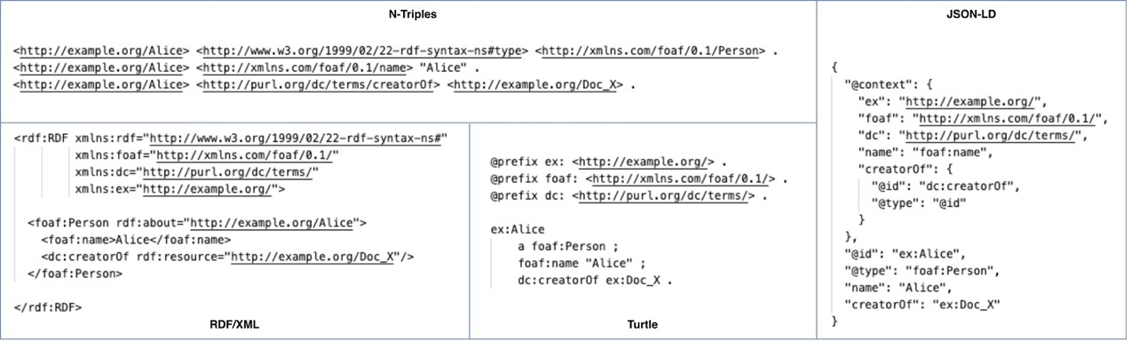
Figure 1 - RDF serialization

Knowledge Representation on the Semantic Web: RDFS and OWL
To enable information systems to process, integrate and reason over stored information, the Semantic Web [BHL01] relies on standardized knowledge representation languages. As described in the previous section, RDF is a foundational model representing information as directed, labeled graphs. While RDF provides a flexible data model, it lacks the vocabulary to define data entities (graph nodes – subjects or objects) and specify the relationships between them. To address this limitation, World Wide Web Consortium (W3C) [cite] introduced and proposes RDF Schema (RDFS) [W3C14b] and the Web Ontology Language (OWL) [W3C12].
RDF Schema (RDFS) extends RDF and provides the tools for implementing schemas and vocabularies [W3C14b]. RDFS allows for the definition of classes, properties, and the hierarchical relationships between them. The main elements introduced by RDFS include:
- Class Hierarchies (rdfs:Class, rdfs:subClassOf), which allow the definition of classes and taxonomies used in the data. For example, when we declare that the class “Professor” is a subclass of the class “Person”, then every person who is a “Professor” is automatically considered a “Person” as well. If an entity is declared as an instance of “Professor”, a reasoner can infer it is also a “Person”.
- Property Hierarchies (rdf:Property, rdfs:subPropertyOf), which allow properties to inherit characteristics from broader properties (e.g., ex:isAdvisorOf is a subproperty of ex:collaboratesWith).
- Domain and Range Restrictions (rdfs:domain, rdfs:range), which define the expected types of subjects and objects associated with a property. If <s, p, o> exists, as well as domain(p) = C and range(p) = C’, then s in C and o in C’.
RDFS allows for the definition of properties and the application of appropriate constraints. A key advantage of RDFS is its support for basic inference. If an individual belongs to a subclass, it can be automatically inferred that it also belongs to its superclass [AHG20]. This capability facilitates the automation of knowledge processing. Despite its benefits, RDFS is not sufficient to express complex logical relationships or constraints, such as class equivalences, cardinality constraints, or mutually exclusive concepts. OWL was created to address these needs.
While RDFS is sufficient for basic taxonomic categorization, it lacks the expressiveness required for complex reasoning, logical consistency checks, and sophisticated class definitions. The Web Ontology Language (OWL) extends RDFS by providing a richer set of vocabulary based on Description Logics (DL), a family of class-based knowledge representation formalisms. It enables the creation of complex knowledge models equipped with advanced logical functions [W3C12]. OWL (specifically OWL 2) categorizes components into three distinct pairwise disjoint vocabularies: Classes (concepts), Properties (roles), and Individuals (constants). With OWL, the following class relationships can be defined: equivalent (owl:equivalentClass) and the same (owl:sameAs - explicitly stating that two different IRIs refer to the identical real-world entity) classes, mutually exclusive classes (owl:disjointWith), cardinality restrictions (owl:cardinality), logical combinations of classes (i.e., classes that can be constructed using set operations: union, intersection, and complement – e.g., using owl:unionOf), specialized properties, existential quantification (owl:someValuesFrom). Furthermore, OWL stands out because it supports specific types of properties, such as symmetric properties, transitive properties, functional properties [HKR09]. In transitive properties, the “ancestor” relationship is characteristic. If A is an ancestor of B and B is an ancestor of C, the system directly infers that A is an ancestor of C. One of its most significant advantages: It supports automated reasoning with reasoners such as HermiT, Pellet, and FaCT++. These reasoners detect logical inconsistencies, automatically classify classes, and discover new knowledge not directly stated in the model [AHG20]. Thanks to all of this, OWL has become a key tool in artificial intelligence, biomedical informatics, semantic search, knowledge management systems, and knowledge graphs.
RDF, RDFS, and OWL work together, complementing one another and building successive layers in the architecture of the Semantic Web [BHL01]. RDF provides the basic model for data representation. RDFS provides mechanisms for defining schemas and hierarchies, while OWL goes a step further, offering advanced capabilities in logical representation and reasoning.

Records in Contexts Conceptual Model (RiC – CM)
The RiC-CM (Records in Contexts – Conceptual Model), developed by the International Council on Archives (ICA), seeks to integrate traditional archival description standards, such as ISAD(G), ISAAR(CPF), ISDF, and ISDIAH, within a unified conceptual framework [ICA21]. Unlike older hierarchical models, the RiC-CM is based on an entity-centric approach. Here, archival information is organized around entities, attributes, and relationships. Its basic idea is that records are not isolated entries, but rather parts of a broader contextual framework involving people, organizations, functions, events, and processes related to their creation, management, and use. This approach enables archival information to be represented in a more multidimensional way and paves the way for data interlinking in Semantic Web and Linked Open Data environments [ICA21].
The basic entities of RiC-CM are the Record or Record Set, which corresponds to the archival record itself or a set of records (e.g., collections, fonds, series, folders). The Agent, is the person, organization, or group that creates, manages, or uses the records. The Function, which relates to activities or responsibilities and is directly linked to the creation of records and the Event, which includes actions and processes such as the creation, transfer, modification, or preservation of records. The model is complemented by entities such as Place and Date, which help to comprehensively capture the historical and functional context of the records [ICA21]. Each entity is accompanied by specific attributes that provide detailed information about its characteristics. For example, the Agent entity includes attributes such as the agent’s identifier, name, type, dates of existence, and administrative or biographical history. Similarly, the Record entity has details such as the title, creation date, language, format, extent, level of description, and technical characteristics of the digital object. These attributes function as semantic units of information and enable the accurate documentation of archival resources [ICA21]. Figure 2 depicts the main hierarchy of the RiC-CM classes.
In RiC-CM, relations (i.e., relationships between entities) are of particular importance, as they serve as the primary means by which entities are linked and the archival framework is represented. Relations are used to indicate, for example, that an Agent creates or manages a Record, that a Record documents a specific Function, or that an Event affects, changes, or transforms a Record. At the same time, relations allow different sets of records, entities, and events to be linked, resulting in the creation of a dynamic information network. This network captures not only the content but also the historical, administrative, and operational context of the records [ICA21]. In Figure 2, we can see the main relations defined by the RiC-CM between the classes.
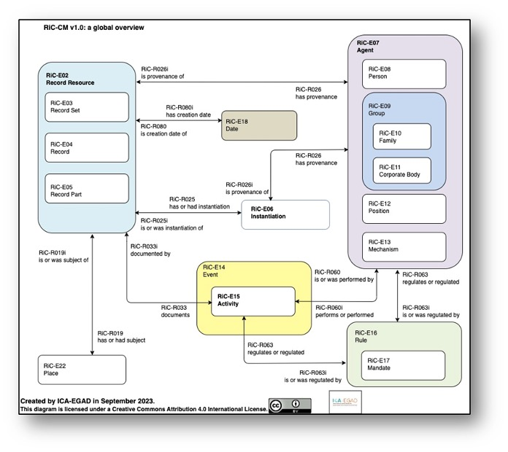
Figure 2 - Overview of RiC -CM Conceptual Model

RiC-O (Records in Contexts Ontology)
RiC-O (Records in Contexts Ontology) implements the RiC-CM conceptual model and was designed by the International Council on Archives (ICA) to facilitate the representation, interlinking, and exchange of archival data within the Semantic Web and Linked Open Data environments [ICA23]. RiC-CM provides the theoretical and conceptual framework, while RiC-O takes the model’s concepts, entities, and relationships and transforms them into a formal ontology based on RDF and OWL technologies. Thus, archival data can be described in a way that machines can understand and linked across different information systems, cultural organizations, and digital repositories [ICA21].
The basic ontological classes of RiC-O are Record Resource, Record Set, Agent, Function, Activity, Event, Place, Date, and Concept. The Record Resource class represents an archival record or digital object. Record Set refers to groups or collections of records. Agent describes individuals, organizations, or groups associated with the creation, management, or use of records. Function and Activity denote the functions and activities that produce or affect records. Event captures events or processes, such as creation, transfer, modification, or preservation in digital form. Finally, Place, Date, and Concept provide geographical, temporal, and thematic documentation for archival information [ICA23]. Every entity in RiC-O has specific properties (data properties for assigning raw data values, and object properties for relating object instances with each other) that help describe its characteristics in detail. For example, the Agent class includes properties such as hasOrHadName, identifier, history, existenceDate, and categoryType. On the other hand, the Record Resource has properties such as title, language, creationDate, extent, format, and scopeAndContent. These properties function as semantic metadata and enable the precise description of both physical and digital archival objects.
RiC-O also uses URI identifiers for the unique identification of each entity, thereby enhancing interoperability with external data and other cultural ontologies [ICA23]. A key component of RiC-O is relationships (i.e., object properties), as they show how entities are connected to one another and make it possible to capture complex archival contexts. Examples of these properties include createdBy, manages, documents, isAssociatedWith, occurredAtPlace, and participatesIn. Through these, it is captured that an Agent created a Record Resource, or that an Event affected a record, or even that a Function is linked to activities and archival collections. These relationships are written as RDF triples (subject–predicate–object), which helps create flexible knowledge networks, rather than merely strictly hierarchical descriptive structures [ICA23]; [DOE03].

PREMIS (Preservation Metadata: Implementation Strategies)
PREMIS (Preservation Metadata: Implementation Strategies) is the best-known metadata standard for digital preservation. It was designed to support the long-term management and preservation of digital objects [PEC15]. The PREMIS Data Dictionary for Preservation Metadata provides a structured framework for recording technical, administrative, and management metadata related to the preservation of digital material. Many digital repositories, libraries, archives, and cultural heritage organizations implement it, resulting in a wide range of applications. Unlike general archival description models, PREMIS focuses exclusively on the needs of digital preservation, prioritizing the authenticity, integrity, accessibility, and long-term usability of digital objects [LAV14].
The conceptual structure of PREMIS is based on four core entities: Object, Event, Agent, and Rights. The Object entity refers to the digital object itself, which can be individual files, bitstreams, or even more complex digital objects. The Event entity is used to record every action or process that affects the digital object, such as migration, normalization, validation, replication, or integrity checking. The Agent describes the individuals, systems, or organizations that undertake or manage preservation activities. As for Rights, this is where the rights and permissions associated with preservation activities as well as access to digital objects are recorded [PEC15]. Each entity has its own specialized semantic units (i.e., attributes) that help accurately document the digital preservation process. For example, the Object entity includes attributes such as objectIdentifier, objectCategory, compositionLevel, fixity, size, format, and creatingApplication. Fixity is particularly valuable as it verifies integrity using checksums and hashing algorithms.
The Event entity includes elements such as eventIdentifier, eventType, eventDateTime, eventOutcome, and eventDetail, allowing every preservation action and its results to be recorded in detail. The Agent has attributes such as agentIdentifier, agentName, and agentType. The Rights entity records permissions, restrictions, and permitted maintenance actions with properties such as rightsBasis, act, and restriction [PEC15]. Relationships between entities are a fundamental aspect of PREMIS, as they link objects, actions, and responsible entities within a comprehensive digital preservation framework. For example, an Event is linked to a specific Object, indicating that a migration or validation was applied to it. At the same time, an Agent is linked to the Event as the person responsible for performing that action, while the Rights entity determines whether the Agent has the right to perform actions such as copying, converting, or reproducing the digital object. Through these relationships, PREMIS creates a detailed information network that documents every stage of the digital object’s lifecycle [PEC15]; [LAV14]. Note that PREMIS model is given in multiple representations/serializations, such as XML Schema (for traditional structured records) and OWL / RDF ontologies (for Linked Data implementations).
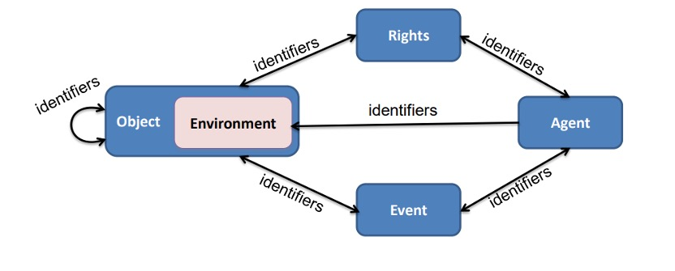
Figure 3 - Overview of PREMIS

Methodology
This thesis adopted a qualitative and conceptual methodological approach, with the aim of exploring how the RiC-CM model can be expanded to meet the needs of digital preservation. Initially, the study was organized into several stages: first, the relevant standards were analyzed theoretically, then, the ontological data were collected and processed, the PREMIS concepts were mapped to RiC-O, conceptual gaps were identified, and finally a proposal for the extension of RiC-CM was formulated. In the first stage, I conducted an extensive literature review on archival description, digital preservation, the RiC-CM models, the ontological implementation of RiC-O, and the PREMIS standard. At the same time, research approaches to semantic interoperability, ontology extensions, and the linking of archival description with preservation metadata were examined. Through this literature review, the theoretical basis of the two standards was understood, and their key differences in terms of function and purpose were identified. In the second stage, data was collected and analysed from the RiC-O and PREMIS ontologies. I began with the structure of RiC-O, focusing on the basic classes, properties, and relationships that play a role in representing archival entities and their contexts. The entities were divided into categories such as Record Resource, Record Set, Agent, Activity, Event, and Rule. At the same time, I noted the datatypes and object properties that semantically link the data, then Ι followed a similar process for PREMIS. I studied the basic classes, namely Object, Event, Agent, and Rights, along with the relationships concerning the preservation of digital objects, their integrity, dependencies, and preservation actions. Once the data had been collected, all entities and properties were systematically recorded in tables, which made it easier to conduct a comparative analysis of the two models. This process identified points where there was a direct correspondence, as well as cases where there was no clear equivalence between the two models. The mapping was based primarily on the semantic function of the concepts, not merely on their nominal similarity. During the mapping phase, different types of semantic relationships were used, depending on how closely the concepts matched one another. Subsequently, an analysis was conducted of the conceptual gaps revealed by the mapping. Based on these results, a proposed conceptual extension of RiC-CM was formulated. In this process, new preservation-oriented relationships were introduced so that the system could capture technical dependencies, integrity information, and the results of preservation actions. At the same time, proposals and methods were implemented to link preservation policies, software tools, and technical mechanisms to the archival entities already present in the model. Finally, the proposed extension was implemented by developing illustrative digital preservation scenarios.

Conceptual Modelling of Digital Preservation in RiC-CM and PREMIS
The PREMIS and RiC-CM standards each have their own distinct role, but they work together effectively in digital preservation. PREMIS focuses primarily on preservation metadata, that is, the technical documentation and details of preservation. On the other hand, RiC-CM focuses on a deeper conceptual representation and highlights the context and surroundings of archival records. When they are used together, we achieve a more comprehensive solution, as they address both the technical needs of preservation and the conceptual challenges that arise in the management of digital cultural heritage. This chapter examines how the PREMIS standard corresponds to RiC-CM, with the aim of incorporating digital preservation requirements into the archival conceptual model. The analysis results from a systematic investigation of the entities defined by PREMIS and how they can be represented through the entities and relationships provided by RIC-CM.

Data collection and Preparation from RiC -O & PREMIS
In the first stage, data was collected from the RiC-O (Records in Contexts Ontology) and an analysis of the ontology’s structure was initiated, during which its key elements were identified. Next, the data was organized into classes, object properties, and datatype properties in accordance with the structure of RiC-O. In addition, the main entities and their relationships were identified, with an emphasis on concepts related to archival description, such as agents, activities, and records. This process contributed to an understanding of the ontology’s semantic structure and the way in which the archival environment is represented. The next step involved collecting data from the PREMIS ontology, which focuses on the preservation of digital objects. In this case, the study focused on categorizing the data into classes and properties, to clearly capture the structure of the ontology. The core entities and their relationships were identified, with an emphasis on concepts such as digital objects, events, and agents, as these are directly related to the management and preservation of digital information. Through this process, a clear picture emerged of the function and role of the PREMIS ontology in digital preservation. Finally, all the data extracted from the two ontologies were systematically organized in a table using Excel, as shown in the figures below, to facilitate the comparison of concepts and to provide a solid foundation for the next step in the methodology, which is the mapping between the two ontologies.

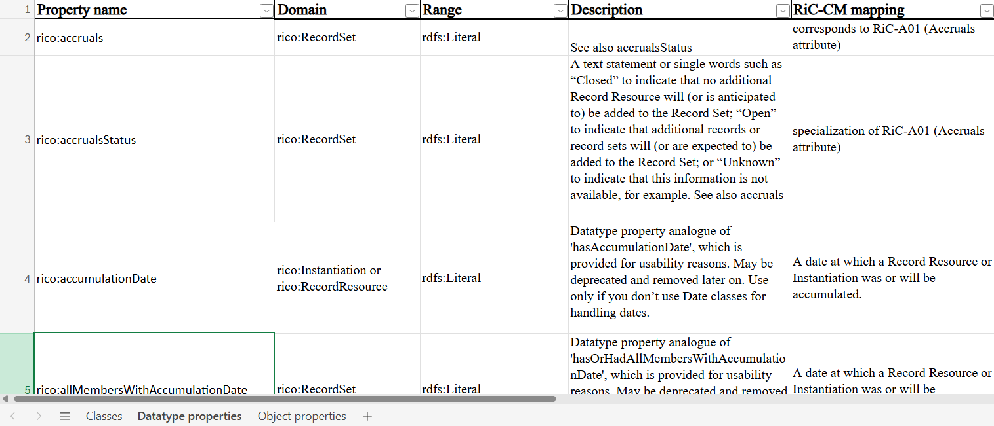
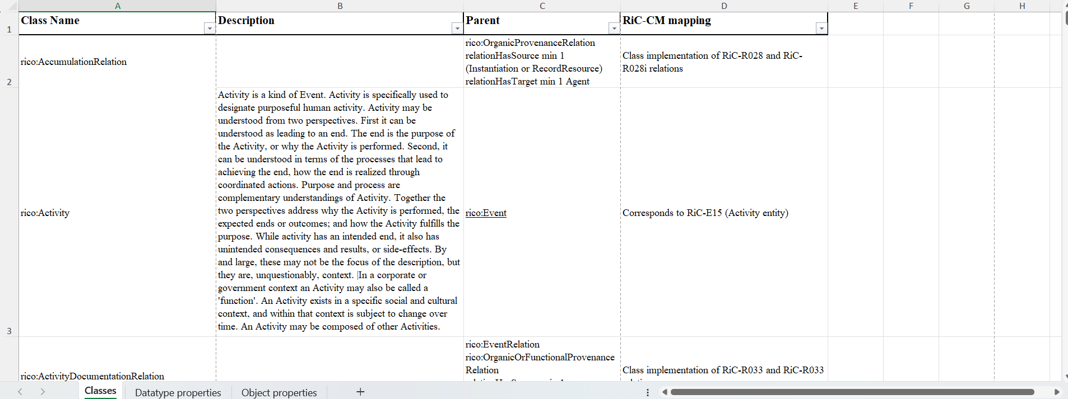
Figure 4 - An excerpt of the datatype properties of the RiC-O ontological model, presenting domains, ranges, descriptions, and mappings to RiC-CM.

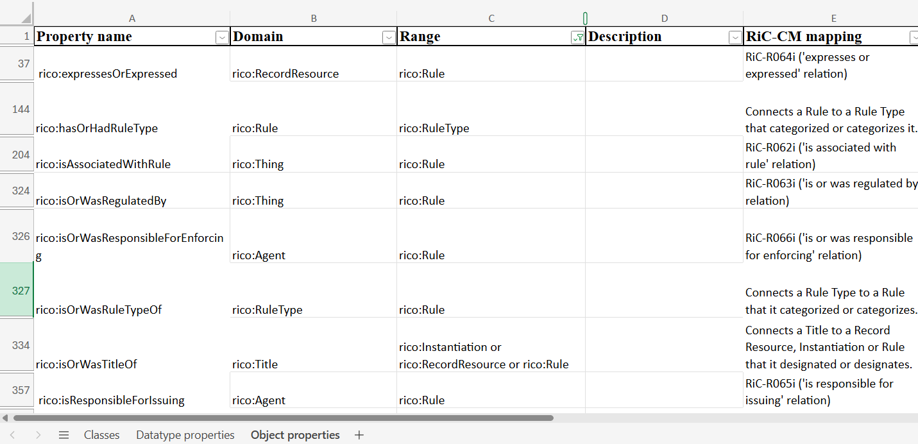
Figure 5 - An excerpt from the object properties of the RiC-O ontological model, showing relationships, domains, ranges, and mappings to RiC-CM.
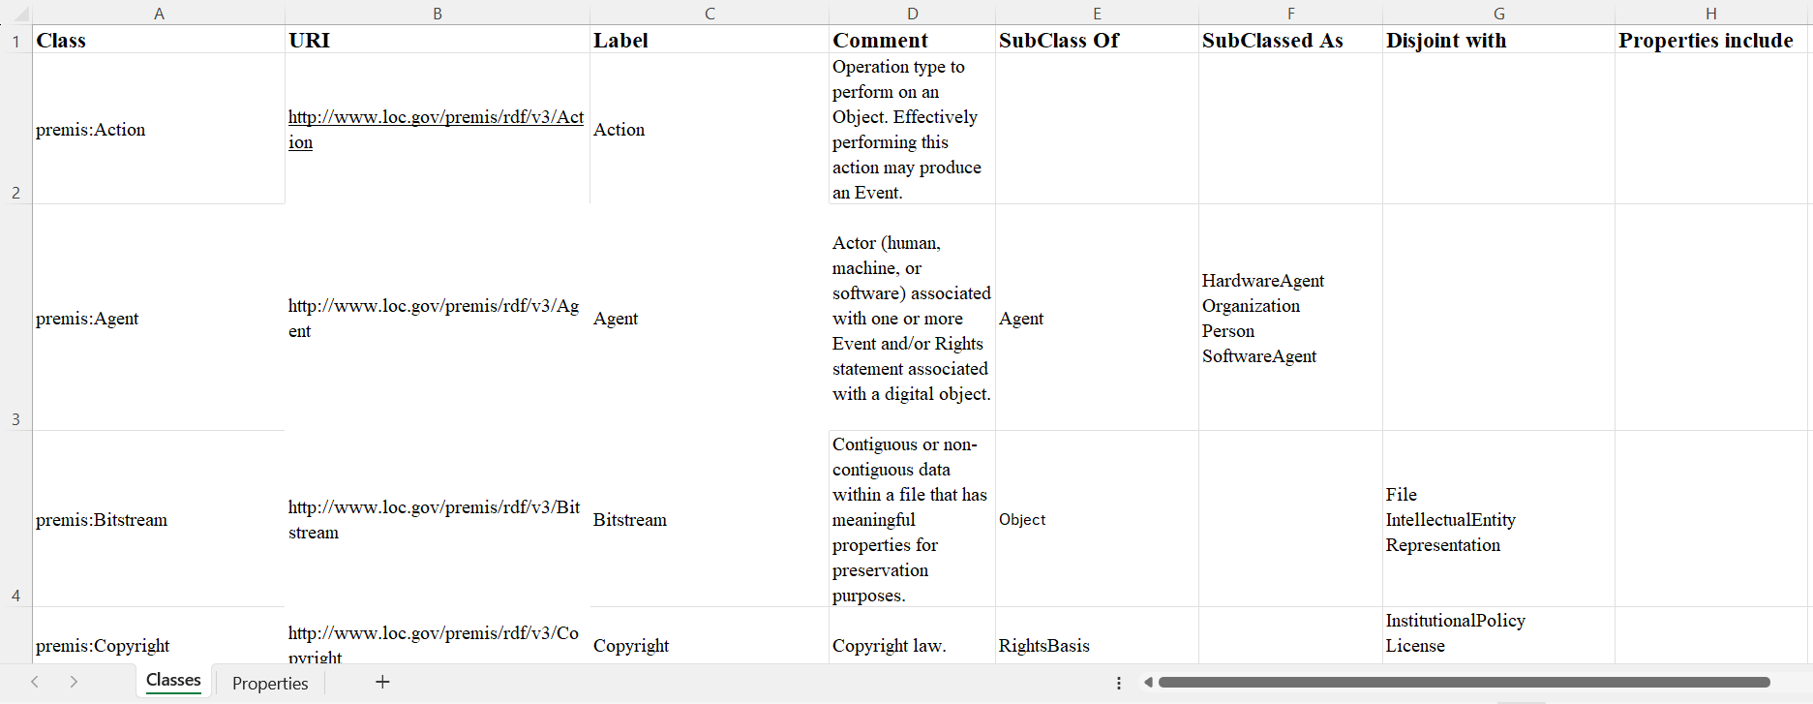

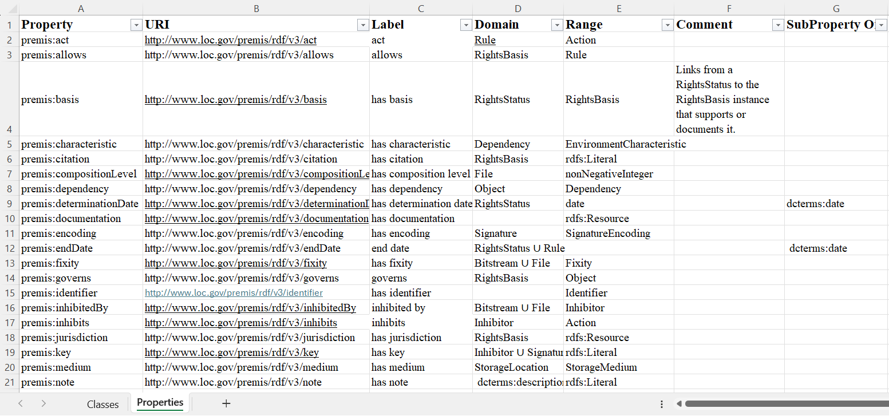

Mapping of PREMIS and RiC-CM

Mapping of IntellectualEntity and RecordResource
Although the IntellectualEntity class in PREMIS and the RecordResource class in RiC-O both refer to information resources, they are not conceptually identical. They express different aspects of information and serve distinct purposes in their respective models. The **IntellectualEntity** in PREMIS describes an abstract intellectual or conceptual entity—the informational content recognized as a single work, regardless of its format or technical implementations. Here, the focus is on the content that is preserved, rather than on the individual digital objects that embody it. On the other hand, the **RecordResource** in RiC-O refers to an archival resource preserved as evidence of an activity or function, embedded in a broader context of relationships with individuals, organizations, functions, and production processes. RiC-O does not stop at informational content; its focus extends to both the documentary nature of the resource and the context in which it was created and is maintained. The fundamental difference between the two concepts lies in the level of abstraction at which they operate. An IntellectualEntity captures the conceptual identity of a work—that is, the meaning it conveys. On the other hand, RecordResource concerns the archival nature of a document—its role as evidence and a source of information. This means that an IntellectualEntity may correspond to one or more RecordResources, but these two categories are not identical as concepts. Thus, when an attempt is made to semantically relate them, their relationship is considered to be a partial correspondence or a close conceptual relevance, but not complete equivalence. For example, a doctoral dissertation is considered an IntellectualEntity in the PREMIS model, since it constitutes a single intellectual work with specific content and semantic coherence. This dissertation can take various forms—a PDF file, a Word document, or even a printed copy—but its intellectual identity remains the same. When it comes to RiC-O, things change. The digital PDF stored in the university’s institutional repository, or the printed copy held in the library, are considered Record Resources. These artifacts exist as evidence of academic activity; they are linked to a specific creator, a specific custodian, and a specific context of production. Thus, the concept of an IntellectualEntity refers primarily to the intellectual work itself, namely the “Doctoral Dissertation.” The physical or digital items that represent it and are preserved in the archive function as Record Resources. This example clearly illustrates the difference: the first concept focuses on the informational content, while the second emphasizes the archival and documentary nature of each resource.

Mapping of Event and Activity
The PREMIS Event class and the RiC-O Activity class describe actions or processes that occur within a specific time frame and are related to other entities in the system. However, the two concepts originate from different conceptual frameworks and serve different functions. In PREMIS, an Event is an action that affects or is related to a digital preservation object. Its primary role is to record the actions that take place during the lifecycle of a digital object: creating backups, integrity checks, format conversion, and ingestion into the repository. The emphasis is on documenting procedures that ensure the authenticity, integrity, and usability of digital resources. The RiC-O Activity class, on the other hand, refers to any action, process, or function performed by an entity—an institution, individual, or organization—that is related to the creation, management, or use of archival records. This concept is more general and is situated within the context of archival description, where activities are directly linked to the administrative, operational, and historical context of the creation and preservation of records. So, while every Event in PREMIS essentially functions as a type of Activity, the reverse is not always true. PREMIS focuses on technical and administrative tasks related to digital preservation. On the other hand, RiC-O covers a broader range of activities related to the creation and management of archival resources. For this reason, the correspondence between the two classes amounts to a close conceptual relationship, not an absolute equivalence. An example: Converting a digital image file from TIFF to JPEG 2000 for the purpose of long-term preservation. In PREMIS, this process is recorded as an “migration” Event—a specific action that alters the digital object and that must indeed be documented in the preservation process. In RiC-O, the same process falls under the “Activity” category—it relates to the organization that carried it out, the archival records affected, and the repository’s overall management framework. However, the Activity class can also describe entirely different actions: an administrative decision, the conduct of a research project, or even the processing of a file. Such activities do not fall under the Events of digital preservation, as defined by PREMIS.

Mapping of Identifier
The Identifier class in PREMIS and the corresponding Identifier in RiC-O are primarily intended to uniquely identify entities within each information system. In both standards, the identifier functions as a distinct attribute that helps distinguish one entity from others in the same category. Essentially, their semantic content is identical—both classes provide the same mechanisms for unique identification, without any semantic differences. Thus, we can consider them fully equivalent in OWL. For example, if a digital object has the identifier “hdl:12345/6789,” we can model it as either a PREMIS Identifier or a RiC-O Identifier without losing any meaning.

Mapping of Agent
The Agent class in both PREMIS and RiC-O describes entities responsible for actions or involved in events and processes related to archival or digital resources. In both models, Agents include natural persons, organizations, and software that assume specific roles within an activity. The purpose, scope, and semantic context of the two classes coincide, so here too the mapping is complete (OWL). For example, a software program that migrates files is an Agent in both PREMIS and RiC-O.

Mapping of Person
The Person class in PREMIS is more specialized; it specifically refers to natural persons who participate in activities or processes related to the preservation of digital resources. In RiC-O as well, natural persons belong to the Agent category, but there is also a specific Person class, which is a subcategory of Agent. Thus, every PREMIS Person is a RiC-O Agent and, specifically, a RiC-O Person. Conversely, however, the broad RiC-O Agent category also includes organizations or collective bodies, so there is no absolute equivalence. Consequently, the most accurate relationship is a specialization (rdfs), not a complete equivalence. Example: The archivist who verifies the integrity of a record is classified as a Person in PREMIS and as a Person (and thus an Agent) in RiC-O.

Mapping of Organization and Group
The Organization class in PREMIS describes institutional or administrative collective entities involved in the management, creation, or preservation of digital resources. The corresponding concept in RiC-O is primarily expressed by the Group class, which is broader and includes organizations, agencies, committees, bodies, and, in general, any collective entity that acts as an agent in the archival environment. The Group is semantically broader than the PREMIS Organization—it covers more forms of collective entities, not just traditional organizations. Therefore, every PREMIS Organization corresponds to a RiC-O Group, but not necessarily the other way around. That is why we represent this relationship as rdfs. A university or a national archive is an Organization in PREMIS and a Group in RiC-O, while an informal working committee can be only a Group in RiC-O without necessarily being an Organization in PREMIS.

Mapping of Object and RecordResource
The PREMIS Object class refers to any digital object that a digital repository preserves and manages. On the other hand, the RiC-O RecordResource class represents an archival information resource preserved as an artifact and a source of information. The two concepts are closely related, as both concern information resources that are preserved and described. Nevertheless, PREMIS focuses on the technical aspects of the digital object, while RiC-O concentrates on its archival and documentary dimensions. A university repository preserves a doctoral dissertation in PDF format. In PREMIS, the dissertation file is defined as an Object, since it is the digital object that the repository preserves and manages. In RiC-O, the same dissertation is considered a RecordResource, because it is an archival information resource that documents an academic activity and is preserved for future access and reference.

Mapping of File, Bitstream and Instantiation
The File, Bitstream, and Representation classes of PREMIS describe different levels of implementation of a digital object. At the same time, the Instantiation class of RiC-O refers to the specific physical or digital embodiment of an archival resource. In both standards, the focus is on exactly how an information resource is realized or stored in a specific format, a feature that highlights their semantic proximity.A historical photograph has been digitized and is stored both as a high-resolution TIFF file and as a JPEG file for online access. In PREMIS, TIFF and JPEG files are classified as Files. The metadata embedded within the TIFF file is treated as Bitstreams. All the files needed to fully represent the photograph together constitute a “Representation.” According to RiC-O, each digital version of the photograph is described as an “Instantiation”—that is, a specific digital instance of the same archival resource.

Mapping of License and RecordResource
The PREMIS License class records licenses, rights, and restrictions associated with the preservation and use of digital objects. Similarly, in RiC-O, the same information is recorded via a RecordResource, which contains the terms of the license or the relevant contract. Thus, the correspondence between the two is based on the fact that licenses are documented and stored as archival resources.An archive receives a collection of digital photographs along with a licensing agreement that permits educational use but prohibits commercial exploitation. In PREMIS, this information is recorded as a “License” because it defines the rights and restrictions on the use of the digital material. In RiC-O, the text of the agreement is considered a “RecordResource” because it constitutes an archival document that captures and substantiates the terms of use for the collection.

Mapping of StorageMedium and CarrierType
The StorageMedium class in PREMIS describes the physical medium on which a digital object is stored, such as magnetic tapes, hard disks, or optical disks. Similarly, the CarrierType in RiC-O serves to describe the type of carrier that transports or stores information. These two concepts are related to the physical or technical means that support the storage and preservation of information resources, although they approach the issue from different perspectives.An organization maintains backup copies of its digital records on LTO magnetic tapes. In PREMIS, the magnetic tape is defined as a StorageMedium because it is the medium on which the digital objects are stored. In RiC-O, the same tape is considered a CarrierType, since it describes the type of physical medium that carries or stores the information. Both standards refer to the same physical medium; they simply approach it from different conceptual perspectives.

Mapping of Dependency and Record
The Dependency class in PREMIS describes the technical dependencies a digital object requires in order to be opened, interpreted, or operated—for example, specific software, an operating system, or an external file. This information ensures that the object remains useful and readable in the future.In RiC-O, the Record class refers to a record resulting from an activity and serving as a carrier of information and documentation. The technical dependencies of a digital object are usually recorded in technical reports or documentation.Thus, the two concepts are linked because the technical information of the Dependency is documented and preserved as a Record in RiC-O. For example: A digital CAD file requires a specific software version. This requirement is recorded as a Dependency in PREMIS, while the technical documentation describing it is stored as a Record in RiC-O.

Mapping of Event and Activity
The PREMIS Event class records events or actions that occur during the lifecycle of a digital object and affect its state. For example, it includes format conversion, integrity checks, or the creation of a backup.In RiC-O, the Activity and Event classes model actions, processes, and events related to the management of archival records. Through these, the history of actions is fully documented. The correspondence here is based on their common function: both models describe events and activities that affect an information resource. Example: Converting a TIFF file to JPEG2000 is recorded as an Event in PREMIS and as an Activity or Event in RiC-O. In both cases, it is a documented action that changes how the documented resource is stored.

Mapping of Fixity and Record
The Fixity class records information for integrity verification, such as checksum and hash values. These confirm that the object remains unchanged over time. In RiC-O, a Record may include the integrity information referenced by Fixity as metadata. Therefore, we make this connection because what Fixity represents can be included in the Record as content and preserved. Example: A repository calculates the SHA-256 of a PDF file, stores the value as Fixity in PREMIS, and this result is documented as an integrity check Record in RiC-O.

Mapping of InstitutionalPolicy and Record
The InstitutionalPolicy class in PREMIS defines an organization’s official policies for the management and preservation of digital resources. It describes procedures, roles, and preservation strategies.In RiC-O, such policies are Records—they document decisions and organizational practices. The connection between them is therefore straightforward: institutional policies exist and are implemented as archival records. Example: A university has a policy to check integrity every six months. This policy is described as an InstitutionalPolicy in PREMIS, and its official document is a Record in RiC-O.

Mapping of PreservationPolicy and Record
The PreservationPolicy defines how digital objects are preserved over the long term. It may involve format conversions or the creation of multiple backup copies. In RiC-O, this policy is found in administrative documents that are preserved as Records. Thus, the connection arises because here, too, the preservation policy is documented and is found as a record. Example: A repository requires that all image files be converted to TIFF for preservation purposes. This is a PreservationPolicy in PREMIS, while in RiC-O the policy document is a Record.

Mapping of OutcomeStatus and Activity
The OutcomeStatus records are the result of an action—whether a process was successful or failed. In RiC-O, the result is linked both to the Activity (i.e., the action being performed) and to the Record that documents the result. Therefore, OutcomeStatus only makes sense in the context of the activity and its documentation. Example: An integrity check is successfully completed. The notation “successful” appears as the OutcomeStatus in PREMIS and as an indicator in the Record of the audit report in RiC-O.

Mapping of Rule and Record
The Rule class describes rules, guidelines, or regulations that affect the management and preservation of digital records. In RiC-O, these rules are found in documents, manuals, or regulations that become Records. Therefore, the mapping is straightforward—the rules are documented as archival records held by the organization. Example: A regulation requires that all digital records have at least two backups. We describe this as a Rule in PREMIS, while the relevant regulatory document is a Record in RiC-O.

Mapping of SoftwareAgent and Record
The SoftwareAgent class records the software systems or applications involved in preservation processes. In RiC-O, information about this software is documented in technical documentation, manuals, or reports that are recorded as Records. In summary, software is documented through archival records. Example: The Archivematica software performs format conversion processes—this is recorded as a SoftwareAgent in PREMIS, while the system’s manual or technical report is a Record in RiC-O.

Mapping of Inhibitor and Record
The "Inhibitor" class in the PREMIS standard describes mechanisms that restrict or prevent access to, use of, or modification of a digital object. This includes encryption, passwords, digital rights management (DRM) systems, and other protection technologies. Recording this data is particularly important for long-term preservation—it allows administrators to know in advance the restrictions that will affect access over time. In RiC-O, the Record class refers to an archival item that preserves information and evidence regarding activities, resources, or processes. Information about access restrictions or technical barriers is often documented in archival records, security reports, or administrative guidelines—all of which are Records in RiC-O. Thus, the two concepts are directly linked: the information recorded by the “Inhibitor” class can be preserved as archival records via “Record” in RiC-O. This ensures the long-term documentation of access restrictions. For example, if a file is encrypted and can only be opened with a specific password, the encryption is recorded as an Inhibitor in PREMIS. The relevant details are documented in a security document, which is recorded as a Record in RiC-O.

Mapping of HardwareAgent and Record
The HardwareAgent class in PREMIS describes devices or hardware equipment involved in the creation, management, or preservation of digital objects. Examples include scanners, servers, storage systems, and other infrastructure. All of these play an active role in digital preservation processes. In RiC-O, the Record class helps document information about the equipment, its specifications, and how it is used. These records allow us to understand the technological environment in which resources are produced or preserved. Information about a HardwareAgent, therefore, is recorded in records described as Records in RiC-O—and thus the technological context of preservation is documented. For example, when digitizing a collection using a high-resolution scanner, the scanner is recorded as a HardwareAgent in PREMIS, and its technical description is documented in a report, which becomes a Record in RiC-O.

Mapping of Action and Record
The PREMIS Action class describes specific actions performed to manage and preserve a digital object. Such actions may include format conversions, integrity checks, backups, data transfers, or other operations that affect the state or preservation of the object. Documenting these actions is critical. This preserves the preservation history and ensures the authenticity of the digital resource. In RiC-O, the Record class refers to an archival record that contains information and evidence regarding activities, processes, or events. Anything that PREMIS records as an action can be documented through reports, logs, reports, or other documents maintained as Records. These documents explain what happened, when, and by whom. The connection between the two concepts lies precisely here: The actions of the Action class are recorded and documented through archival records. PREMIS focuses on the action itself as a preservation act, while RiC-O is concerned with the artifact that records this action and provides the relevant documentation.Example: A repository converts an image file from JPEG to TIFF for long-term preservation. This conversion is recorded as an “Action” in PREMIS. The corresponding report—including the date, the software used, and the result of the process—is stored as a “Record” in RiC-O.

Mapping of Statute and Rule
In the PREMIS standard, the “Statute” class refers to legislative or regulatory provisions that establish requirements, rights, or restrictions regarding the management, preservation, and access to digital objects. These provisions stem from the legal framework and establish mandatory rules that organizations must follow when managing their data. The “Rule” class in PREMIS records any type of rule, policy, or regulation that affects digital resource preservation processes. Based on this logic, a “Statute” functions as a specific type of “Rule,” since it is a legally binding rule that clearly defines how organizations must manage their digital objects. This connection makes it possible to describe not only the rule itself but also its legal basis. For example, a law on the protection of personal data may impose restrictions on access to records containing sensitive information for a specific period of time. This law is registered as a Statute in PREMIS and is simultaneously used as a Rule to specify the access restrictions on the specific digital items.

Mapping of Copyright and Rule
On the other hand, the “Copyright” class in PREMIS describes copyrights that specify who may reproduce, distribute, modify, or use the digital object, and under what conditions. Copyright sets specific terms that limit user actions, directly affecting both the management and preservation of digital content. Within the PREMIS framework, the “Rule” class refers to any rule, policy, or regulation related to the use and management of digital resources. Since copyrights impose binding legal conditions on the use of a work, they are considered a specific category of Rule. This association allows digital preservation systems to document legal restrictions alongside the digital object, thereby ensuring that these restrictions are upheld in the future. Thus, for example, a digitized book that is protected by copyright and may not be reproduced or distributed online without the author’s permission, this information is included in PREMIS as “Copyright” and simultaneously functions as a “Rule” that defines the permitted uses of that specific digital object.

The isDocumentedBy relationship
The isDocumentedBy relationship indicates that an entity, concept, or resource is described, recorded, or documented through an archival artifact or information resource. Essentially, this relationship links the object that is the subject of the documentation to the resource that contains the relevant information. When we say IntellectualEntity isDocumentedBy RecordResource, we mean that the information pertaining to an intellectual object is recorded and stored in an archival resource. This ensures that the entity is accompanied by documentation describing its characteristics, origin, management, and/or use. For example, a digitized manuscript is an IntellectualEntity in PREMIS. Information about the creator, the date of digitization, usage rights, and its preservation history is recorded in a metadata file or an archival record—that is, in a RecordResource in RiC-O. Consequently, the digitized manuscript (IntellectualEntity) isDocumentedBy that specific RecordResource, because this record provides the basic documentation needed to understand and manage the object.

The isActivityContextOf relationship
The isActivityContextOf relationship (serves as the activity context for) indicates that an event acts as the context within which an activity takes place. On the other hand, the hasActivityContext relationship (has as an activity context) links an activity to the event that encompasses or documents it. The connection between a PREMIS Event and a RiC-O Activity is based on the fact that both classes refer to actions that occur within a specific time frame and affect information resources or generate new ones. A PREMIS Event can provide the documentary context for an activity in RiC-O, while an activity can indicate the relevant event as the context in which it was performed. For example: a digital file is converted from TIFF to JPEG for accessibility purposes. This conversion is recorded in PREMIS as a migration-type event. In the RiC-O archival model, this action is recorded as an Activity because it is part of the process of managing and preserving digital resources. The PREMIS Event functions as an isActivityContextOf for the specific RiC-O Activity, while the RiC-O Activity has the corresponding PREMIS Event as its activity context (hasActivityContext). Thus, the technical documentation of the action is directly linked to the archival description of the activity.

The "represents" relationship
The "represents" relationship indicates that one entity serves as a representation or embodiment of another. In PREMIS, the Object class encompasses any digital object that is worthy of preservation: these can be files, sets of files, or digital entities more generally. On the other hand, in RiC-O, the RecordResource class refers to an archival resource that contains information or evidence regarding actions, individuals, or organizations. When we link premis:Object to rico:RecordResource via the “represents” relationship, we are stating that the PREMIS digital object is a digital representation of an archival resource in RiC-O. Thus, the technical aspect of digital preservation is directly linked to the archival description of the content. For example: a digitized document in PDF format is recorded as an Object in PREMIS. The same document, when viewed as an archival artifact—a carrier of information and evidence—is described in RiC-O as a RecordResource. The digital file (Object) essentially represents the corresponding RecordResource.

The "is described by" relationship
The "is described by" relationship is used when you want to show that an entity is not only documented but also described in detail through an archival resource. In other words, the RecordResource does not simply note the existence of the license, but provides details—it explains, analyzes, or presents its characteristics. In PREMIS, the License class refers to the license that defines which rights and restrictions apply to a digital object: how someone may access, reproduce, distribute, or modify it. In RiC-O, a RecordResource can be any archival item, document, or even metadata, as long as it describes an information entity. The link premis:License is described by rico:RecordResource thus shows that the terms and characteristics of a specific license are described—concretely and comprehensively—within an archival resource. For example: You have a digital file available under a Creative Commons license, and you record this in PREMIS as “License.” The terms—such as the requirement to attribute the creator, the prohibition on commercial use, and the restriction on modification—are detailed in a license document or metadata file. In RiC-O, this document is a RecordResource. Thus, the License is described by that specific RecordResource.

The "documents" relationship
The "documents" relationship indicates when an archival record contains information about a mechanism that restricts access or use. In PREMIS, the Inhibitor class describes technologies or methods that restrict or block access to a digital object—such as encryption, passwords, or DRM. In RiC-O, the Record class can hold information that describes precisely these restrictions. Thus, this relationship makes it possible to document the technical barriers related to accessing digital content.For example, if a file is encrypted and requires a special password to open, this encryption is recorded as an Inhibitor in PREMIS. The relevant details are recorded in a security document, which in RiC-O is treated as a Record and documents the specific Inhibitor.

The hasAgent relationship
The hasAgent relationship indicates who is responsible for an activity—whether it is a person, an organization, or a system. In RiC-O, the Activity class covers every action or process related to the management of archival material. In PREMIS, the Agent class describes the entity involved in digital preservation processes. This association helps clearly identify who performed an action, ensuring accountability and traceability for all actions. Example: When converting a file from TIFF to PDF/A, the activity is recorded as an “Activity” in RiC-O. The software or archivist that performed the action is recorded as an “Agent” in PREMIS. In practice, the “Activity hasAgent Agent” relationship indicates who was responsible.

The “documents” relationship
The “documents” relationship (documents) is also used to indicate that an archival record contains information about a rule concerning the management, access, or preservation of digital content. In PREMIS, the Rule class covers policies, regulations, legislation, or any other framework that governs what can be done with a digital object. In RiC-O, the Record class represents the archival record that contains such information or evidence. This is how the rules applicable in the digital environment are documented through archival records.Example: An administrative document stipulating that only authorized users have access to personal data is recorded as a Record in RiC-O and documents the corresponding Rule in PREMIS.

The “documents” relationship
The “documents” relationship indicates that an archival record documents or describes a specific action taken in the context of managing a digital object. According to PREMIS, the “Action” class refers to actions or processes involved in the creation, modification, transfer, or preservation of a digital resource. Through this association, actions are preserved as documented evidence. Example: A record documenting the transfer of a file to a new storage medium is a Record in RiC-O and documents the corresponding Action in PREMIS.

The hasOutcomeStatus relationship
The hasOutcomeStatus relationship links an activity to the outcome that resulted when it was executed. In RiC-O, the Activity class describes a process or action performed in an archival or information environment. In PREMIS, OutcomeStatus records whether the outcome was successful, failed, or completed with warnings. This relationship helps us evaluate and monitor preservation processes. Example: A file conversion process completes without errors. The corresponding Activity in RiC-O is linked to the OutcomeStatus “success” in PREMIS via the hasOutcomeStatus relationship.

The wasGeneratedBy relationship
The wasGeneratedBy relationship indicates that an archival artifact was created as a result of a specific activity. RiC-O places particular emphasis on documenting the origin of archival resources and linking them to the activities that created them. Through this relationship, information about how and why a record was created is preserved. Example: Following an integrity check, a results report is generated. This report is a Record and wasGeneratedBy the audit activity, which is represented as an Activity.

The wasAssociatedWith relationship
The wasAssociatedWith relationship indicates that a software system performed or supported an activity. In PREMIS, the SoftwareAgent class is used for applications or software involved in the management and preservation of digital objects. Thus, this association helps document the tools used during the execution of an activity.For example, in file format recognition, the DROID software carries out the process. In this scenario, the Activity in RiC-O is linked via wasAssociatedWith to the specific SoftwareAgent in PREMIS.

The actsAs relationship
On the other hand, the actsAs relationship indicates that a software agent fulfills the role of the mechanism that enables a process to function. In PREMIS, a SoftwareAgent is the software that intervenes in preservation events, whereas in RiC-O, the Mechanism class refers to the means by which the activity is implemented. Thus, this association indicates the functional role of the software in the archival environment. Another example: Archivematica automatically performs digital records management and preservation processes. In PREMIS, Archivematica is described as a SoftwareAgent, while in RiC-O it is described as actsAs Mechanism, because it is the means by which these activities are carried out.
The Person rdfs:subClassOf relationship indicates that one class is a more specific instance of another, more general class. For example, the Person class in PREMIS is a subclass of Agent in RiC-O. In other words, every person recorded in PREMIS is automatically considered an Agent in RiC-O. In PREMIS, the term “Person” refers to a natural person involved in activities related to the creation, management, or preservation of digital objects. On the other hand, in RiC-O, the “Agent” class is broader: it includes any entity that can take action or participate—whether it is a person, an organization, or a group.With this connection, the natural persons in PREMIS fit seamlessly into the broader framework of RiC-O agents, which facilitates the interoperability and collaboration between the two standards. For example, if an archivist performs an integrity check on a digital file, they are recorded as a Person in PREMIS. Because of their role in managing digital resources, they are also an Agent in RiC-O.
The same applies to organizations. The rdfs:subClassOf relationship defines that an Organization is a specific type of Group. Thus, every organization mentioned in PREMIS can be considered a specific category of group in RiC-O. In PREMIS, “Organization” refers to an organization, institution, company, or other collective entity that participates in the creation, management, or preservation of digital objects. In RiC-O, the “Group” class covers any set of individuals that functions as a single entity capable of acting or interacting with archival resources. This connection is based on the fact that every organization is essentially an organized group of people with a common purpose and functions. Thus, PREMIS organizations fall under the broader category of Groups in RiC-O. A typical example: The National Library of Greece is listed as an “Organization” in PREMIS because it is involved in the management and preservation of digital collections. In RiC-O, the same entity is considered a “Group,” since it constitutes an organized group of individuals with common administrative and operational characteristics.
The rdfs:subClassOf property indicates that every member of a class is a special case of a broader class. Here, the RiC-O Record is considered a specific form of InstitutionalPolicy in PREMIS when the archival item contains or expresses institutional policies related to the management and preservation of digital resources. InstitutionalPolicy in PREMIS refers to official policies, rules, or guidelines adopted by an organization that shape its practices regarding the preservation of digital material. Within RiC-O, a Record may include these policies, such as documents, decisions, or regulations. Thus, the archival record serves as a vehicle for institutional policy.Example: An official archival document that defines the rules for accessing digital records is described as a Record in RiC-O. Since it expresses the organization’s policy, we also view it as an InstitutionalPolicy in PREMIS.
The rdfs:subClassOf relationship itself indicates that a Record can be considered a specific type of PreservationPolicy when its content outlines strategies and procedures for the long-term preservation of digital objects. In PREMIS, a PreservationPolicy refers to policies that define how an organization safeguards the authenticity, integrity, and accessibility of digital resources. In RiC-O, these policies are often found in archival documents that are recorded as Records. This correspondence helps us view archival records as vehicles for digital preservation policies.Example: A document specifying that the integrity of all digital records will be checked every six months and that multiple backup copies will be maintained is recorded as a Record in RiC-O. Because it defines the organization’s official preservation strategy, it is also considered a PreservationPolicy in PREMIS.
The rdfs:subClassOf relationship indicates that the Statute class is a more specific instance of the Rule class. Statute refers to a legislative or regulatory provision that imposes obligations, rights, or restrictions on the management of digital resources. Since every such provision functions as a rule that must be followed, it clearly belongs to the Rule category.Consider, for example, the General Data Protection Regulation (GDPR). It is both a Statute and a Rule, since it sets specific rules for how we manage personal data.
Similarly, the rdfs:subClassOf relationship indicates that Copyright is a specific subclass of the Rule class. Copyright defines terms of use, copying, and distribution for a digital object. These terms are legally binding, which is why Copyright is classified as a subclass of Rule. For example, a digital book is protected by copyright, which prohibits copying without the author’s permission. Copyright is a specific type of Rule because it specifies exactly when and how you are allowed to use the digital work.
The mapping between the PREMIS and RiC-O classes is not always straightforward. The two models follow different philosophies, have different scopes of application, and serve different descriptive purposes. PREMIS focuses primarily on the management and preservation of digital objects within the context of digital preservation. RiC-O, on the other hand, was designed for archival description and the management of relationships and contexts among archival entities. Thus, some classes were found to correspond directly due to their semantic proximity. Others, however, had no clear equivalent in RiC-O, resulting in them either being mapped indirectly or ultimately remaining unmapped.
1.Example for Semantic link between the Intellectual Entity class (PREMIS) and the Record Resource class (RiC-O) using the ex:isDocumentedBy property
The following, provides an example of how to model archival and digital information using RDF/Turtle, based on the PREMIS and RiC-O metadata standards. The example refers to a digitized archival collection and a digital archival artifact, demonstrating how they are semantically linked. Through classes, properties, and tags, the model demonstrates how information is organized and linked in a digital archiving and cultural documentation environment.
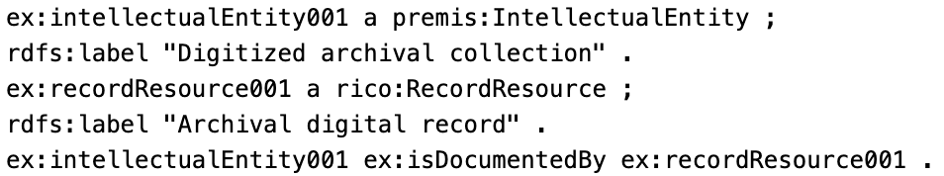
In this exercise, you are asked to analyze the entities and relationships that appear in the RDF model and to explain the role of the PREMIS and RiC-O standards in shaping the description of archival and digital materials. Basically, there are two main entities: ex:intellectualEntity001, which belongs to the premis:IntellectualEntity class, and ex:recordResource001, which belongs to the rico:RecordResource class. The first entity represents a digitized archival collection, labeled “Digitized archival collection.” The second refers to an archival digital record, labeled “Archival digital record.” The IntellectualEntity class serves to represent an intellectual or logical object, whether it is an entire collection, a book, or a single digital file. Similarly, RecordResource describes an archival record or information resource, which serves as a means of documenting information and activities. The relationship between these two entities is defined by the ex:isDocumentedBy property, which indicates that the digitized archival collection is documented through that specific archival digital resource.

2. Example for Semantic Mapping between Preservation Events (PREMIS) and Archival Activities (RiC-O)

The following presents an example of modelling events and activities using the RDF/Turtle language and the PREMIS and RiC-O standards. The example describes a digital migration event and its connection to a digital migration activity through semantic relationships. The goal is to demonstrate how different metadata standards can work together to represent actions, processes, and events related to the management and preservation of digital archival material.
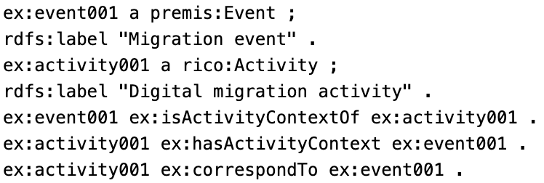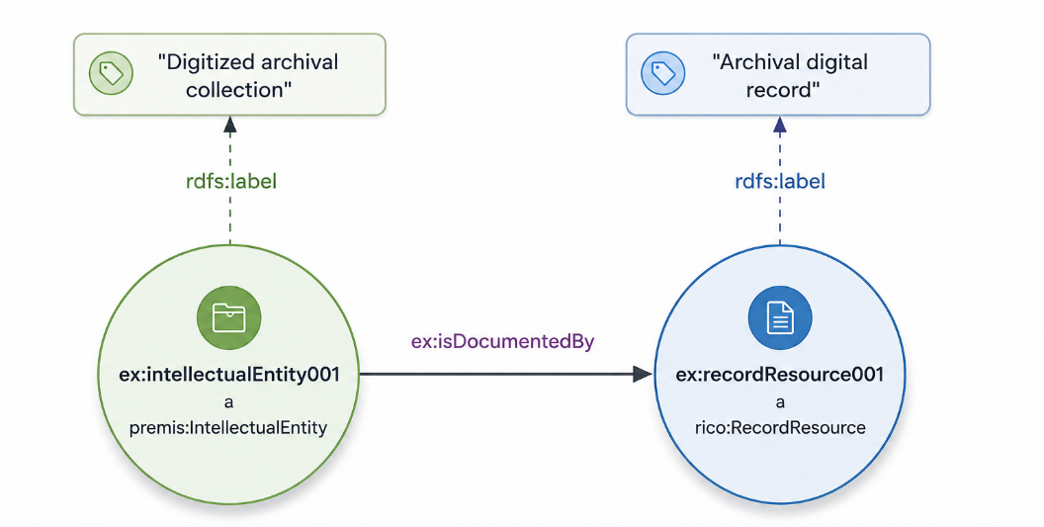
In this example, the entity ex:event001 belongs to the class premis:Event and has the label “Migration event”. According to the PREMIS standard, an Event refers to an event or action applied to a digital object—such as format conversion, data migration, or integrity checking. On the other hand, the entity ex:activity001 belongs to the rico:Activity class and is accompanied by the tag “Digital migration activity.” In the RiC-O model, an Activity is defined as an activity or process related to the creation, management, or preservation of archival material.The relationship ex:isActivityContextOf essentially indicates that the migration event provides the context or background for the specific digital migration activity. On the other hand, the ex:hasActivityContext relationship indicates that the activity is directly related to and depends on the specific event, which serves as a reference. Finally, the ex:correspondTo property expresses a direct correspondence or association between an activity and an event, emphasizing that they refer to the same process, merely through different metadata models or perspectives.

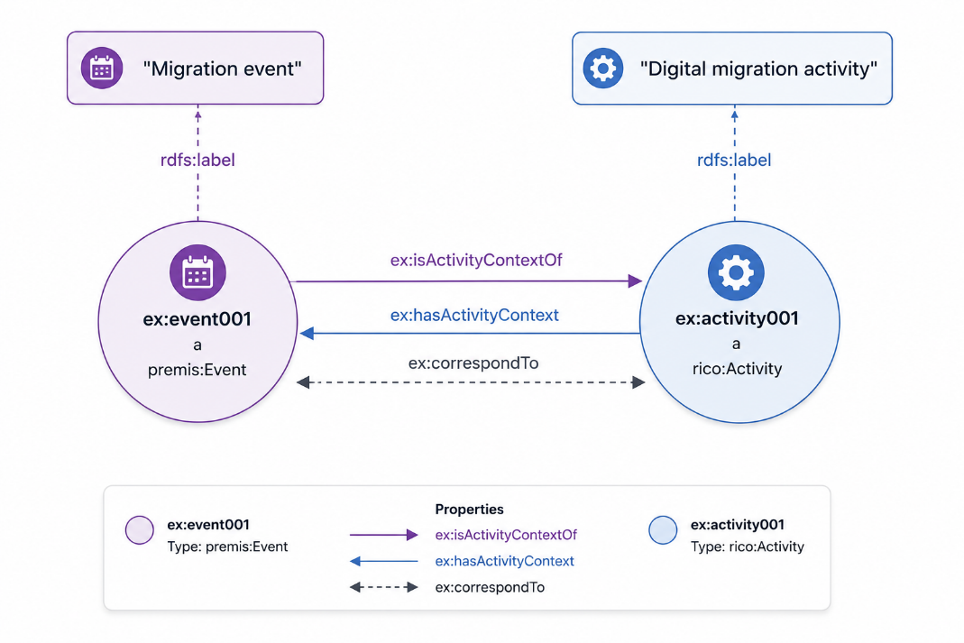
3. Example for Semantic Link between Agent, Person and Organization Classes (PREMIS), the Agent and Group Classes (RiC-O) using rdfs:subClassOfrelationships
The following demonstrates how agents, individuals, and organizations are modeled using RDF/Turtle, leveraging the PREMIS and RiC-O standards. The example explains how hierarchical relationships are established between classes of different ontologies and how this aids in describing individuals or organizations involved in the management of digital archival material. Using the rdfs:subClassOf property, specialization relationships are implemented between the classes of PREMIS and RiC-O, contributing to interoperability between different metadata standards.
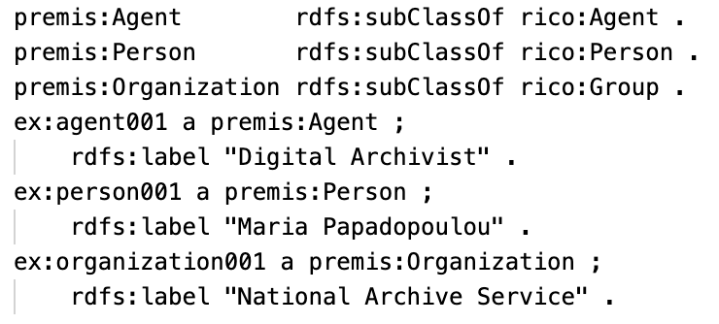
In this example, the statement `premis:Agent rdfs:subClassOf rico:Agent` indicates that every entity of the `premis:Agent` class is automatically considered a member of the `rico:Agent` class. For example, the entity ex:agent001 belongs to premis:Agent and is described as “Digital Archivist.” That is, we are referring to someone who plays an active role in the process of digital archiving and preservation.Something similar occurs with the statement premis:Person rdfs:subClassOf rico:Agent. Here, every person belonging to PREMIS is also treated as an agent within the RiC-O model. The entity ex:person001 is classified under premis:Person and is labeled “Maria Papadopoulou,” representing a natural person who can participate in archival activities or contribute to the preservation of digital objects.Similarly, the statement premis:Organization rdfs:subClassOf rico:Group indicates that every organization in PREMIS is identified as a group or collective in RiC-O. The entity ex:organization001 belongs to the category premis:Organization and is labeled “National Archive Service.” This represents an organization that manages records.The example clearly demonstrates that subClassOf specializations facilitate the connection between different ontologies and lead to the seamless integration of metadata under a common semantic framework.
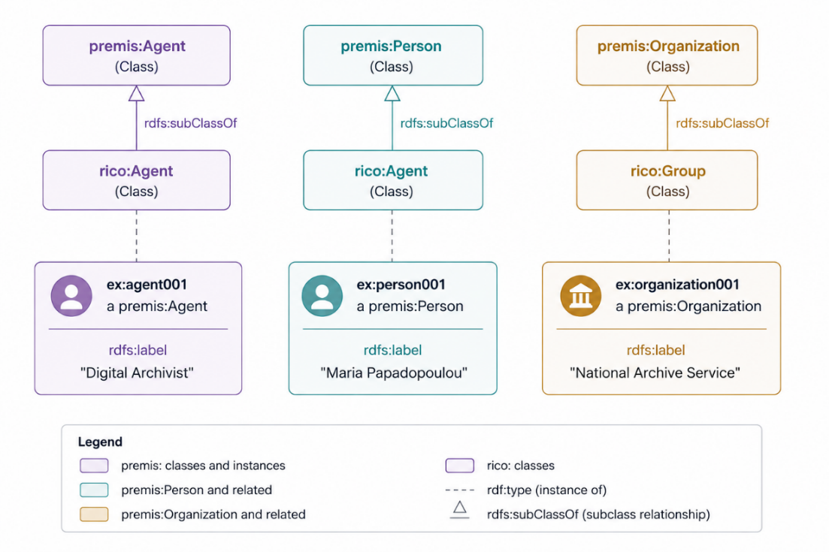
4. Example for Semantic Link between the Object Class (PREMIS) and the Record Resource Class (RiC-O) using the ex: isRepresentedBy property
The following provides an example of how digital objects and archival resources are modeled using the RDF/Turtle language, in accordance with the PREMIS and RiC-O standards. The example demonstrates how a digital object is semantically linked to an archival information resource that represents or documents it. Using RDF classes and properties, the relationship between a digital manuscript and a preserved archival resource is illustrated. This method of description facilitates the management and description of digital archives in an interoperable, coherent manner.
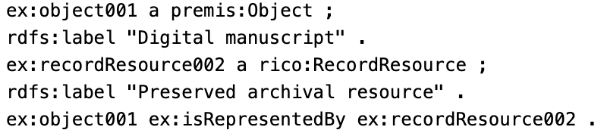
In this example, the entity ex:object001 belongs to the class premis:Object and has the label “Digital manuscript.” In the PREMIS schema, the Object class describes digital objects preserved in a digital preservation system, such as files, images, documents, or digitized manuscripts. This object is the primary digital artifact managed by the system. The entity ex:recordResource002 belongs to the class rico:RecordResource and has the description “Preserved archival resource.” In the RiC-O model, RecordResource denotes an archival information resource that contains or organizes documented information related to archival material. The relationship ex:isRepresentedBy indicates that the digital object is represented or documented by this specific archival resource. In other words, recordResource002 serves as the informational or archival representation of the digital manuscript. This link better organizes and manages the data, as it connects the digital object itself to its archival documentation.The example demonstrates how different semantic standards combine and work together to build comprehensive models of digital preservation and archival description.
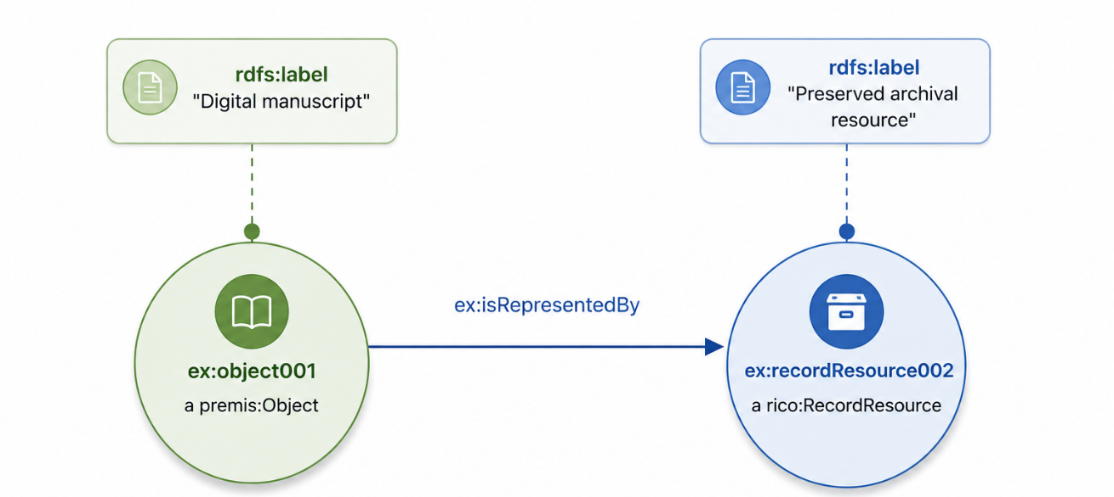
5. Example for Semantic Equivalence between the File, Bitstream, Representation Classes (PREMIS) and the Instantiation Class (RiC-O) using owl:equivalentClass relationships
The following provides an example of how to model digital files, bitstreams, and representations using the RDF/Turtle language and the PREMIS and RiC-O standards. The example demonstrates how certain PREMIS classes can be considered equivalent to the rico:Instantiation class in RiC-O, utilizing the owl:equivalentClass property. This achieves a meaningful mapping of concepts between different ontologies and facilitates communication between systems involved in digital preservation and archival description.
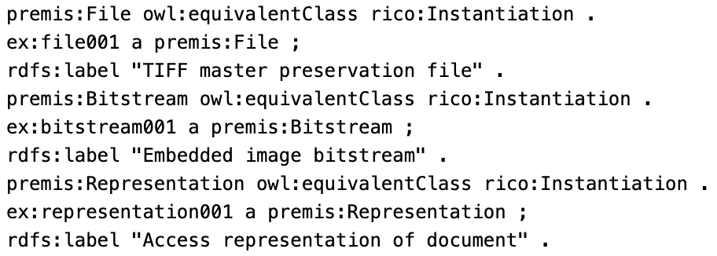
In this example, the relationship `premis:File owl:equivalentClass rico:Instantiation` means that the `premis:File` class is considered equivalent to the `rico:Instantiation` class. In other words, a file in PREMIS can be regarded as a specific instance or form of an archival resource in RiC-O. The entity ex:file001 belongs to premis:File and is described as a “TIFF master preservation file”—a high-quality master file suitable for long-term digital preservation.Similarly, the statement premis:Bitstream owl:equivalentClass rico:Instantiation indicates that the premis:Bitstream class is also semantically equivalent to the concept of “Instantiation” in RiC-O. The entity ex:bitstream001 belongs to premis:Bitstream and is labeled “Embedded image bitstream.” In PREMIS, a bitstream is a set of data within a digital file—e.g., an embedded image or a piece of multimedia content.Furthermore, the statement premis:Representation owl:equivalentClass rico:Instantiation links premis:Representation to rico:Instantiation. The entity ex:representation001 is described as “Access representation of document” and constitutes a way of presenting or accessing the digital artifact, for example a version created specifically for users to view.This example clearly demonstrates how the owl:equivalentClass property can link concepts across different semantic models.
6. Example for Semantic Link between the Storage Medium Class (PREMIS) and the Carrier Type Class (RiC-O) using the ex:correspondsTo property
This exercise demonstrates how to model storage media and carrier types using RDF/Turtle in conjunction with the PREMIS and RiC-O standards. The example explains how a physical or digital storage medium is linked to a type of archival carrier, utilizing the relationships provided by RDF. This linkage provides a more meaningful description of the physical or technical form of digital objects and documents their archival content with greater precision.
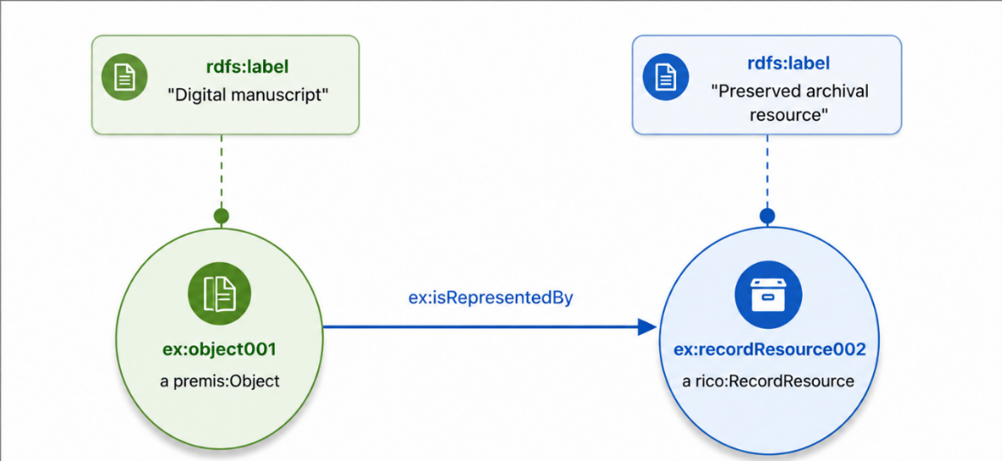
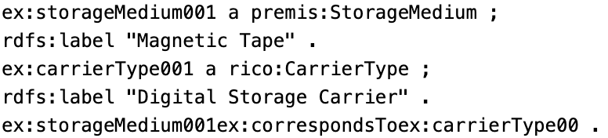
In this example, the entity ex:storageMedium001 belongs to the class premis:StorageMedium and has the label “Magnetic Tape”. According to the PREMIS standard, the StorageMedium class describes the physical or technical medium on which digital data is stored—magnetic tapes, hard drives, optical storage media. The storage medium is essential for the long-term preservation of digital objects, as it directly affects the accessibility and sustainability of the data.The entity ex:carrierType001 belongs to the rico:CarrierType class and is described as “Digital Storage Carrier.” In the RiC-O model, the CarrierType class is used to classify the types of carriers used for storing or transporting archival resources and information.The ex:correspondsTo relationship indicates that this specific storage medium is associated with this specific carrier type. That is, “Magnetic Tape” is considered a type of “Digital Storage Carrier” within the archival and semantic framework of RiC-O. This association allows for the mapping of concepts across different metadata standards and enhances interoperability between digital preservation and archival management systems.This example demonstrates how technical information about storage media can be integrated into a broader semantic and archival framework.
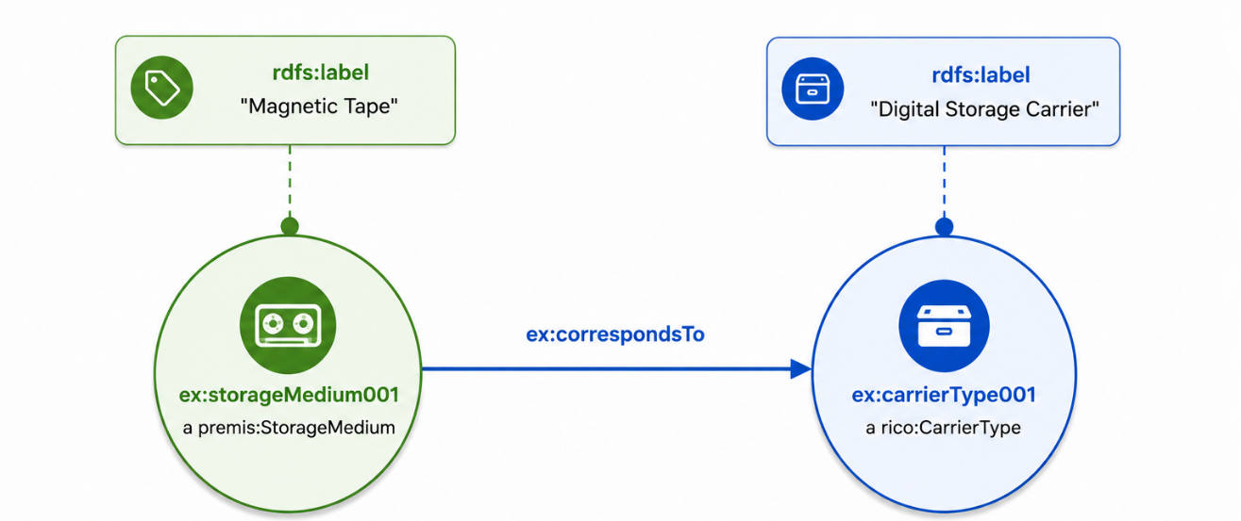
7. Example for Semantic Link between the Institutional Policy and Preservation Policy Classes (PREMIS) and the Rule Class (RiC-O) using the ex:isDocumentedBy property
The following exercise presents an example of modeling preservation policies and archival management rules using the RDF/Turtle language and the PREMIS and RiC-O standards. The example demonstrates how different digital preservation policies are linked to a common archival rule through semantic relationships in RDF. Thus, it demonstrates how an organization’s policies are linked to the rules it uses to document or implement them in a digital preservation environment.
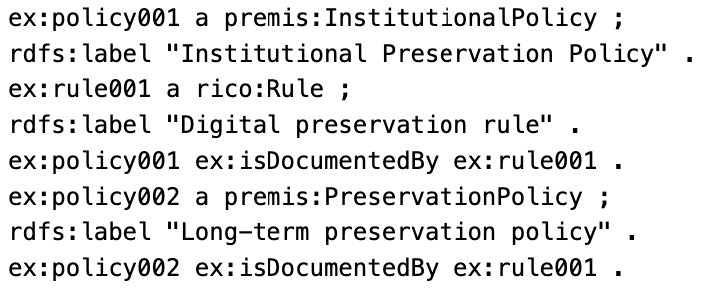
In this example, the entity ex:policy001 belongs to the class premis:InstitutionalPolicy and is described as an “Institutional Preservation Policy.” This specific class in PREMIS represents institutional policies, that is, the rules by which an organization manages and preserves its digital objects. On the other hand, ex:policy002 belongs to the premis:PreservationPolicy class and is labeled “Long-term preservation policy.” This policy relates to strategies and procedures concerning the long-term preservation of digital material. The entity ex:rule001 belongs to the class rico:Rule and is described as “Digital preservation rule.” In RiC-O, Rule describes rules, regulations, or guidelines followed in archival procedures and information management. In both cases, we use the ex:isDocumentedBy relationship to show that policy001 and policy002 are documented by the same rule, rule001. This means that this particular rule serves as a common documentary or regulatory framework for these two preservation policies. The use of a common rule reveals how different policies can be grounded in the same basic guidelines or principles for managing digital material. The example clearly illustrates the combination of the PREMIS and RiC-O standards with the aim of creating interconnected models of policies and rules for the preservation of digital content.
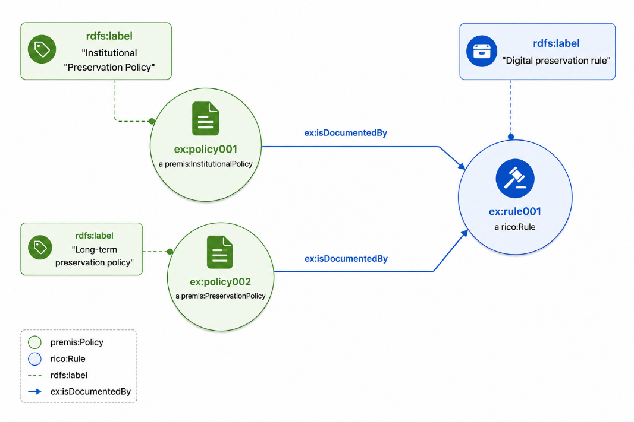
8.Example for Semantic Link between the Outcome Status Class (PREMIS) and the Activity Class (RiC-O) using the ex:hasOutcomeStatus property
This exercise presents an example of modeling digital preservation outcomes and activities using the RDF/Turtle language, leveraging the PREMIS and RiC-O standards. The example explains how a verification or preservation activity is linked to the result state that arises from its execution. By using the semantic relationships of RDF, the connection between an integrity verification process and the result it produces becomes clear.
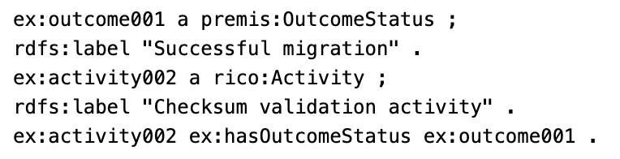
In this example, the entity ex:outcome001 belongs to the class premis:OutcomeStatus and is described as “Successful migration”. The PREMIS standard uses the OutcomeStatus class to record the status or outcome of a process involving digital objects—such as a successful migration, a failed verification, or the completion of a preservation check. The entity ex:activity002 belongs to the rico:Activity class and is labeled “Checksum validation activity.” According to the International Council on Archives RiC-O model, the Activity class represents actions or processes related to the creation, processing, management, or preservation of archival and digital material. In this example, the activity is the checksum verification, that is, the process by which the integrity of a digital object is verified. The relationship ex:hasOutcomeStatus indicates that activity002 resulted in the status outcome001. In other words, the checksum verification activity led to a successful outcome, described as “Successful migration.” This link allows us to document not only the actions performed on a digital object, but also the results produced by them. This example highlights how important it is to clearly link processes and results in digital preservation systems.
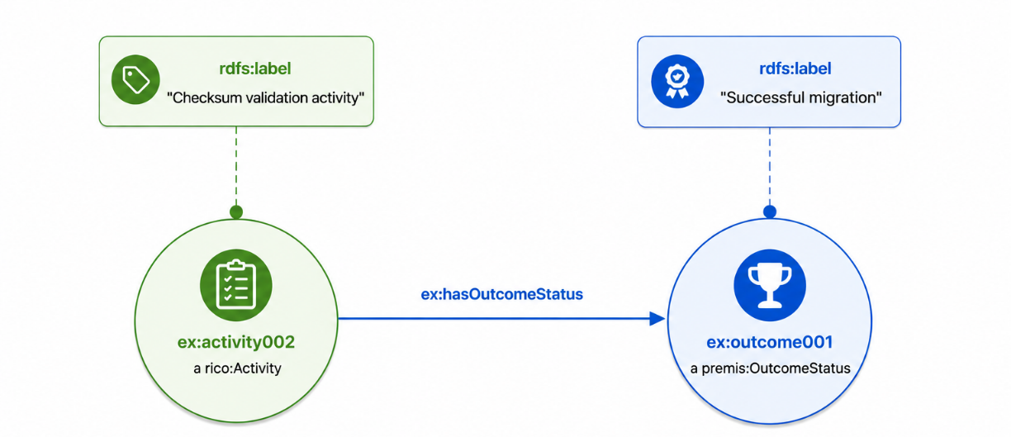
9.Example for Semantic Link between the Rule Class (PREMIS) and the Record Class (RiC-O) using the ex:documents property
The following exercise provides an example of how access rules and archival records are modeled using the RDF/Turtle language, based on the PREMIS and RiC-O standards. The example explains how a management or access restriction rule can be linked to the archival record that reflects or documents it. Using RDF relations, the relationship between a regulatory rule and a documentation record containing relevant information is clearly shown.
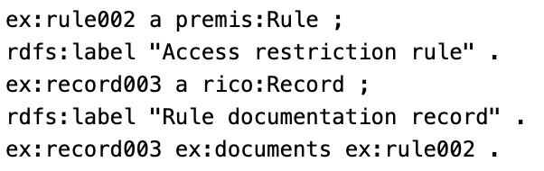
In this example, the entity ex:rule002 belongs to the class premis:Rule and is described as an “Access restriction rule.” In the PREMIS standard, the Rule class represents rules, guidelines, or restrictions that affect the management, preservation, and access to digital objects. Here, the rule defines access restrictions for informational or archival material.The entity ex:record003 belongs to the rico:Record class and is characterized as a “Rule documentation record.” In the International Council on Archives’ RiC-O model, the Record class describes archival records or documents that contain information about an organization’s activities, events, rules, or procedures.The relationship ex:documents means that the archival record record003 documents the rule rule002. In other words, this record functions as an informational or administrative record containing details regarding the specific access restriction rule. This link clarifies the documentation of regulatory procedures and links the procedures to the corresponding records.The example demonstrates how different semantic standards can work together to organize and document policies and rules within a digital archival environment.
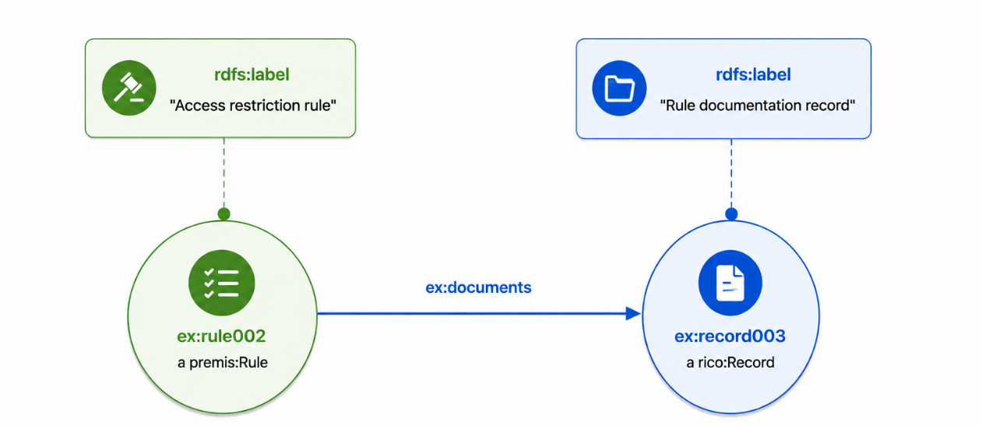
10. Example for Semantic Link between the Action Class (PREMIS) and the Record Class (RiC-O) using the ex:documents property
This exercise demonstrates how to model digital preservation actions and archival records using the RDF/Turtle language, in accordance with the PREMIS and RiC-O standards. The example explains how an action applied to digital objects is semantically linked to the archival record that documents or describes it. Through RDF relationships, it shows how a normalization process relates to the archival record containing the relevant information.
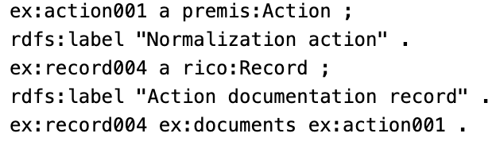
In this example, the entity ex:action001 belongs to the class premis:Action and is labeled as “Normalization action.” In the PREMIS schema, the Action class describes actions or processes that we apply to digital objects in the context of their preservation and management. Normalization—that is, the conversion of a file into a standard or more stable format—is a fundamental process for the long-term accessibility of the file.The entity ex:record004 belongs to the rico:Record class and is labeled “Action documentation record.” According to the International Council on Archives’ RiC-O model, the Record class is used to describe records that document information related to events, processes, activities, or administrative actions.Through the ex:documents relationship, it becomes clear that the archival record record004 records and documents the action action001. In simple terms, this specific record serves as a log of the normalization process. This linkage preserves the history of actions on digital objects and enhances the transparency and reliability of digital preservation processes.This example demonstrates how the PREMIS and RiC-O standards can be combined to create interconnected semantic models. Models that support the recording of actions, the management of documentation files, and the long-term preservation of digital resources.
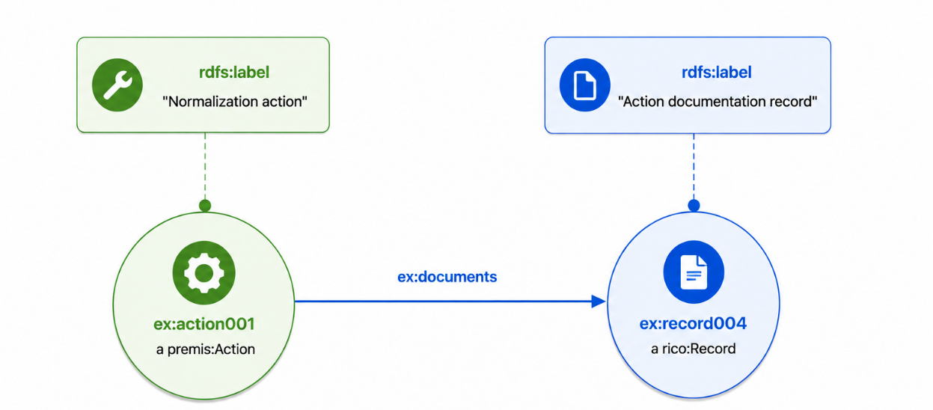
11. Example for Semantic Link between the Software Agent Class (PREMIS), the Activity Class (RiC-O), and the Record Class (RiC-O) using the ex:wasAssociatedWith and ex:wasGeneratedBy properties
This exercise presents an example of how software agents, automated management activities, and archival records are modeled using the RDF/Turtle language, along with the PREMIS and RiC-O standards. The example explains how a digital preservation software tool is linked to an automated data entry activity and how this process results in the creation of a new archival record. By recording the RDF semantic relationships, it is clearly illustrated how the software, the various processes, and the resulting files interact within a digital preservation environment.
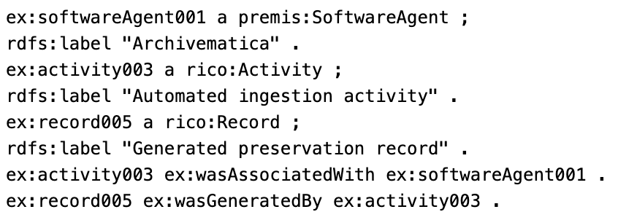
In this example, the entity ex:softwareAgent001 belongs to the class premis:SoftwareAgent and is described as “Archivematica.” Archivematica is an open-source software system that assists in the management and long-term preservation of digital records. Within the PREMIS standard, the SoftwareAgent class includes software or automated systems that participate in digital preservation processes. The entity ex:activity003 is classified in the rico:Activity class and is titled “Automated ingestion activity.” According to the International Council on Archives’ RiC-O model, the Activity class describes processes or actions related to the creation, processing, or management of archival material. Here, it refers to the automatic ingestion of digital objects into a preservation system. The entity ex:record005 belongs to the rico:Record class and has the description “Generated preservation record.” This record is an archival document created during the import process and contains information regarding the preservation of the specific digital material. The ex:wasAssociatedWith relationship indicates that activity003 is associated with or implemented using the software agent softwareAgent001. Essentially, Archivematica is the software that implemented or supported the automated ingestion. The ex:wasGeneratedBy relationship indicates that the record005 was produced by activity003. This directly captures the causal relationship between the process and the resulting output.This example highlights the importance of the semantic link between software, processes, and generated records in digital preservation contexts.
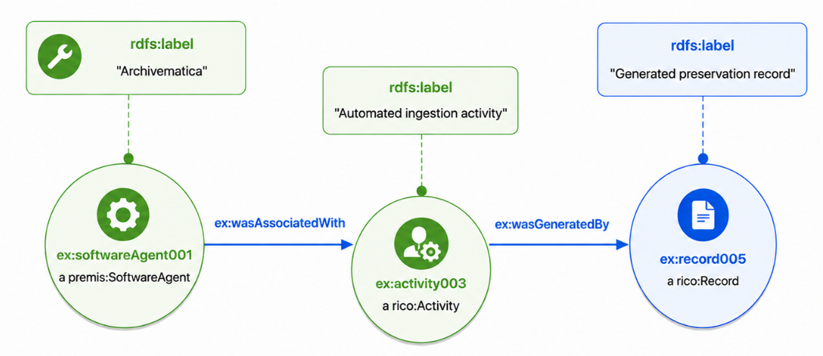
12. Example for Semantic Link between the Dependency Class (PREMIS) and the Record Class (RiC-O) using the ex:hasDependency property
This exercise demonstrates how to model software dependencies and archival records using the RDF/Turtle language and the PREMIS and RiC-O standards. The example explains how a technical dependency—related to the performance or display of digital objects—is semantically linked to the archival record that documents or describes it. Using RDF relationships, the connection between the specific technical dependency of the software and the record containing the relevant information is clearly represented.
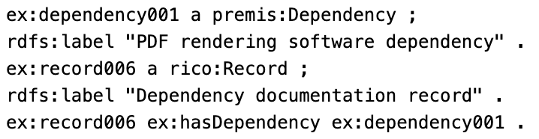
In this example, the entity ex:dependency001 belongs to the class premis:Dependency and is described as “PDF rendering software dependency”. In the PREMIS standard, the Dependency class is used to describe technical dependencies required for accessing, viewing, or properly functioning a digital object. These dependencies may relate to software, operating systems, libraries, or other technological infrastructures necessary for the utilization of digital content. Here, there is a dependency concerning PDF rendering software.The entity ex:record006 belongs to the rico:Record class and is labeled “Dependency documentation record.” Within the International Council on Archives’ RiC-O model, the Record class describes archival records that organize information regarding activities, procedures, technical requirements, or administrative data.The ex:hasDependency relationship indicates that the archival record record006 includes or relates to the dependency dependency001. In other words, this record serves as documentation of the technical requirement necessary for viewing or utilizing a digital object. Thus, technical information necessary to preserve and ensure access to digital records over time is systematically recorded. This example highlights the importance of documenting technical dependencies when discussing digital preservation.
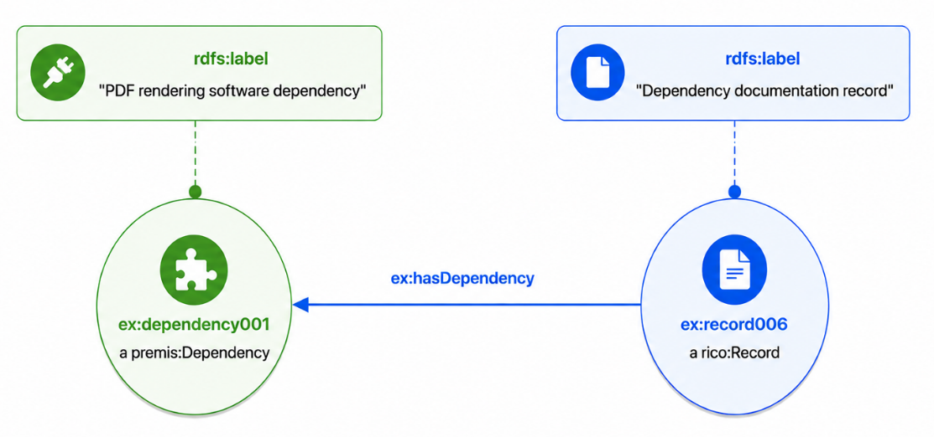
13. Example for Semantic Link between the Fixity Class (PREMIS) and the Record Class (RiC-O) using the ex:represents property
The exercise below provides an example of how integrity information and archival records can be modeled using RDF/Turtle and the PREMIS and RiC-O standards. The example demonstrates how an integrity check mechanism is semantically linked to an archival record that represents or documents it. Using RDF relationships, a link can be established between a fixity record and an integrity verification record, which is relevant to the preservation of digital objects.
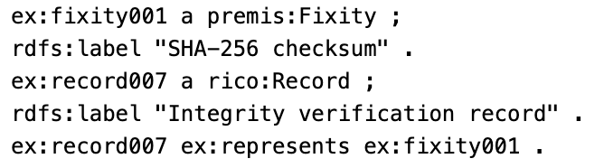
In this example, the entity ex:fixity001 belongs to the class premis:Fixity and is defined as an “SHA-256 checksum.” In the PREMIS standard, the Fixity class is directly related to information about the integrity of a digital object—whatever is needed to determine whether the data has remained unchanged, such as a checksum or other verification methods. Checksums help determine whether a file has been corrupted or remains intact, whether because it was stored somewhere, transferred, or simply kept for a long time. Here, the SHA-256 algorithm is used, which is considered one of the best-known and most widely used methods for ensuring integrity. On the other hand, the entity ex:record007 belongs to the rico:Record class and bears the label “Integrity verification record” . According to the International Council on Archives’ RiC-O model, the Record class describes archival records that contain information related to processes, events, or even technical details of the digital objects themselves.The ex:represents relationship indicates that the archival record record007 represents—or precisely records—the integrity information fixity001. In simpler terms, this record captures the checksum used to verify the integrity of a digital file. This link enables the organized documentation of integrity verification procedures and enhances the reliability of digital files. Ultimately, the example demonstrates how critical it is to maintain fixity information in every digital preservation environment.
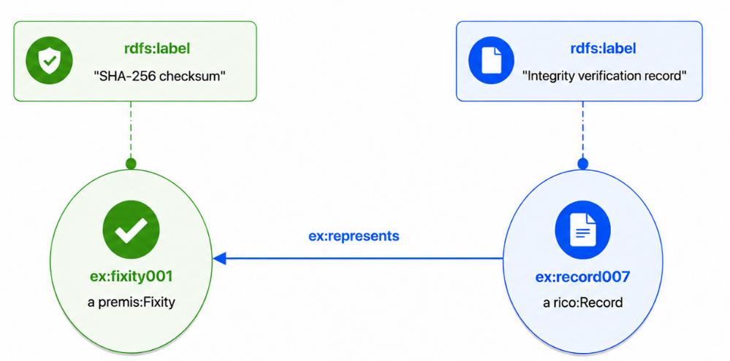
14. Example for Semantic Link between the Statute and Copyright Classes (PREMIS) and the Rule Class (PREMIS) using rdfs:subClassOf relationships
The following exercise demonstrates how legal and regulatory rules are modeled using the RDF/Turtle language and the PREMIS standard. The example demonstrates how individual categories, such as legislation or copyright restrictions, are organized into hierarchies using the rdfs:subClassOf property. This semantic structure clarifies the specialization relationship between general rules and the more specific forms of regulations that affect the management of and access to digital or archival objects.
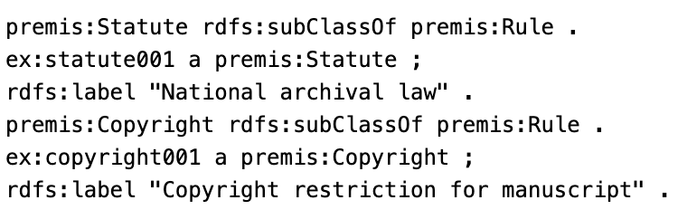
In this example, the statement `premis:Statute rdfs:subClassOf premis:Rule` indicates that the `Statute` class is a subclass of the broader `Rule` class. Thus, every entity that belongs to `premis:Statute` automatically belongs to `premis:Rule` as well. For example, the entity ex:statute001 is in the premis:Statute class and is described as “National archival law.” This is a legal rule, or a legislative provision, related to the management and preservation of records.Similarly, the statement premis:Copyright rdfs:subClassOf premis:Rule specifies that the Copyright class is also a subclass of Rule. The entity ex:copyright001 belongs to premis:Copyright and has the label “Copyright restriction for manuscript.” This entity expresses a copyright restriction that applies to a digital or archival item, such as a manuscript. The rdfs:subClassOf property helps create hierarchical relationships between concepts, making it easier to organize and categorize metadata. With this structure, specific categories of rules, such as laws and copyrights, are incorporated into a broader framework of rules and regulations as subcategories.This example highlights the importance of the semantic organization of legal and administrative information in digital preservation environments.
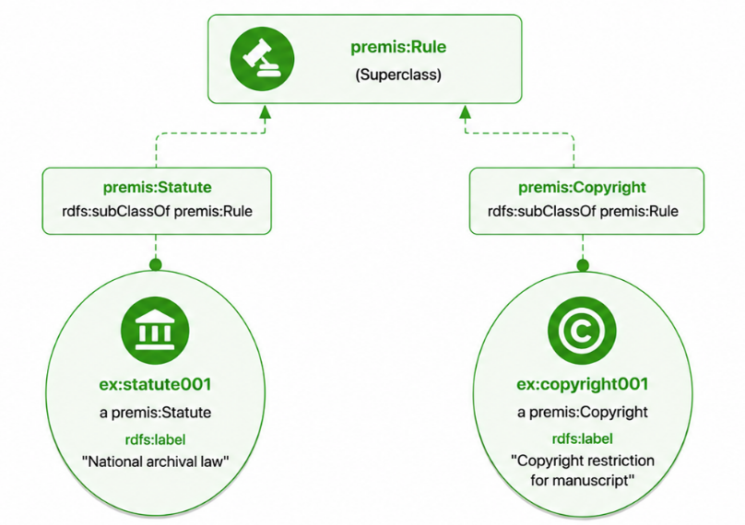

Conceptual Gaps and Limitations
Despite the strong convergence between the PREMIS and RiC-O models, specific conceptual gaps emerge during the mapping process. These gaps stem from differences in design philosophy, level of abstraction, and the very purpose of the two models. A characteristic example arises when PREMIS concepts do not have a direct mapping in RiC-O. The PREMIS entity:Action, for instance, is not fully covered by any RiC-O class, as RiC-O prefers to use broader concepts, such as rico:Activity. This difference indicates that PREMIS chooses to provide a more detailed and specialized modeling of conservation actions, while RiC-O remains more abstract in its logic.
Some concepts, such as premis:StorageLocation and premis:RightsStatus, do not have a direct counterpart in RiC-O. This is because RiC-O does not address technical or legal details regarding preservation. Its approach is more descriptive and focuses on archival relationships. Therefore, such information must be represented in a more indirect way, using properties or additional modeling. There is another important issue: documentation takes a different form in the two standards. In PREMIS, premis:Fixity, for example, is considered a key element for the integrity of digital objects. In RiC-O, there is no direct representation of this concept. Integrity can be documented through records that log its verification or existence, without being specified by a specific property.
There is also a difference in the way the two models represent policies and rules. The concepts premis:InstitutionalPolicy and premis:PreservationPolicy do not have a direct counterpart in RiC-O, but they can be incorporated as subclasses of more general rule categories that exist in RiC-O. This means that we need to extend or adapt the model to fully address preservation needs.There is also a broader conceptual gap related to the different focuses of the two standards: PREMIS deals primarily with the management of digital preservation, while RiC-O focuses on the semantic representation of archival contexts. This fundamental difference creates asymmetries that cannot be resolved simply by mapping between the models.

Proposed Conceptual Extension of RiC - CM based on PREMIS mapping for Digital Preservation
The mapping between the PREMIS and RiC-O models showed that, despite many conceptual similarities, there are still significant gaps in the ability to represent concepts related to digital preservation. Taking into account the findings of the mapping exercise, a conceptual extension of RiC-CM is proposed to incorporate key concepts of digital preservation without altering the model’s basic structure and philosophy.

Extension for Representing the Integrity of Digital Objects
One of the key conceptual gaps that emerged concerns the representation of the integrity of digital objects. In PREMIS, the concept of Fixity covers the recording of checksums, hashing algorithms, and verification procedures that indicate whether a digital object has remained unchanged. RiC-CM, on the other hand, lacks a corresponding mechanism. For this reason, it is proposed to introduce a relationship such as “hasFixity,” so that a Record or an Instantiation can be linked to information regarding its integrity. Thus, data such as SHA-256 checksums, verification dates, or audit results can be integrated into the archival framework without disrupting the model’s consistency.This addition enhances RiC-CM and enables it to effectively cover the processes of verifying the authenticity and integrity of digital records, a fundamental requirement for their long-term preservation.

Extension for Representing Technical Dependencies
Digital objects often require specific software, codecs, applications, or technical environments in order to be opened and used. PREMIS refers to the concept of “Dependency,” but RiC-CM does not provide a specific way to indicate these technical requirements. To fill this gap, it is proposed to add the “hasDependency” relationship. This way, one can link each digital file to the technical tools or environment it requires. For example, a video can be associated with a codec such as FFV1 or with software such as FFmpeg, which are necessary to access or convert it.Accurately representing technical dependencies is of great value for preserving the accessibility of digital objects. It allows for the documentation of the technological requirements needed for someone to use them in the future.

Extension of Digital Preservation Initiatives and Their Outcomes
Digital preservation requires various actions—migration, normalization, validation, and replication are just a few of them. PREMIS documents these processes in detail through the Event entity. In contrast, RiC-CM is limited to broader terms, such as Activity and Event. Despite their semantic similarity, RiC-CM lacks a tool to capture the outcome of a preservation action. Therefore, it is proposed to add relationships such as “hasOutcomeStatus.” This makes it possible to record whether a preservation process was successful or not.

Extension for Conservation Policies and Rules
Digital preservation requires various actions, such as migration, normalization, validation, and replication. PREMIS records each of these in detail through the Event entity (PREMIS Editorial Committee, 2015). On the other hand, RiC-CM uses more general concepts such as Activity and Event (ICA, 2021). Although these concepts are certainly related, RiC-CM does not provide a way to record the outcome of a preservation action. For this reason, it is proposed to introduce relationships such as “hasOutcomeStatus”, so that you can indicate whether a preservation process succeeded or failed.

Extension for Software and Technical Mechanisms
Digital preservation relies primarily on technological tools: software, OCR systems, scanners, and digital preservation platforms keep everything alive. While RiC-CM does include the term “Agent,” it does not clarify when the agent is a person and when it is a technical system. That is why it makes sense to add relationships such as “actsAsMechanism,”“wasAssociatedWithSoftwareAgent,”and“wasGeneratedByActivity.” This makes it possible to link preservation actions to specific technical tools and applications, providing precision and clarity in the documentation.

Application of Proposed Model in Digital Preservation Scenarios

Digital preservation scenario for a historical photograph
Develop a detailed digital preservation workflow for historical photographs, utilizing the PREMIS and RiC-O standards, and incorporating specific data (dates, formats, software, agents, integrity metadata, and preservation policies). Additionally, the entire workflow from the physical artifact to the digital repository should be documented, with an emphasis on authenticity, integrity, and traceability.
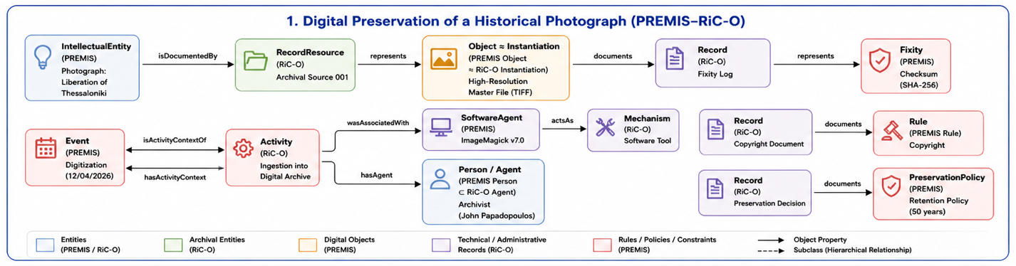
The scenario centers on a historical photograph titled “Liberation of Thessaloniki,” which serves as the intellectual entity at the heart of the scenario. Within the RiC-O model, this entity is linked to a Record Resource, indicating that the artifact is part of and described within an organized archival system. The intellectual entity has a direct link to its digital object: a high-resolution TIFF image file, which serves as its digital representation. The creation of the digital file is linked to an Event of the Digitization type, which took place on 04/12/2026 and is the result of the digitization process. This event is directly attached to the digital object. The event itself is part of an activity titled “Ingestion into Digital Archive,” which involves adding the digital object to the repository. This activity is clearly linked to the digital archive. The execution of both the activity and the related event depended on two agents: archivist John Papadopoulos, who bore the human responsibility, and the ImageMagick v7.0 (Software Tool), which served as the technical mechanism of the process. Throughout this entire process, various records were created that are linked either to the digital object or to the activity. The Fixity Log pertains to the Object, ensuring its integrity via a SHA-256 checksum. The Copyright Document relates to specific rules defining copyright and terms of use, while the Preservation Decision is linked to the process of preserving the digital object. All rules regarding copyright and usage are included in the respective files (Copyright Document), clearly defining the framework for use. Ultimately, all of the above elements constitute a broader Preservation Policy, which covers the entire process and establishes a preservation period of fifty (50) years.

Digital preservation scenario for a video testimony
Develop a detailed digital preservation workflow scenario for a video testimony, utilizing the PREMIS and RiC-O standards. The scenario should model the relationships between key entities, such as Intellectual Entity, Record Resource, Records, Actions, Activities, Agents, Dependencies, and Rules. Furthermore, the digital preservation process must be fully documented, including the migration of the digital object (e.g., format conversion), the recording of technical dependencies (such as codecs), as well as the involvement of human and software factors.
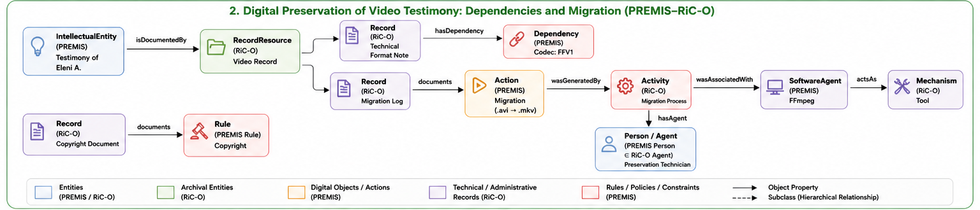
This scenario examines, step by step, how a video testimony titled “Testimony of Eleni A.” is digitally preserved, utilizing the PREMIS and RiC-O conceptual models to describe both the entities and the relationships between them. Initially, the video testimony functions as an Intellectual Entity, which is documented (isDocumentedBy) by an archival resource (Record Resource) titled “Video Record.” This record resource provides the context in which the record is described and managed.The record resource is linked to two main technical and administrative records: the Technical Format Note and the Migration Log. The Technical Format Note is linked (hasDependency) to a dependency specifically related to the FFV1 codec—and this indicates the technical requirement necessary to preserve the digital video. At the same time, the Migration Log documents an action of the Migration type (.avi → .mkv). This action records the conversion of the file from one format to another to ensure its preservation.This specific action is the result (wasGeneratedBy) of an activity titled Migration Process. This activity constitutes the structured framework within which the migration of the digital object takes place.The activity is associated (wasAssociatedWith) with a software agent, namely the FFmpeg tool, which is used to perform the conversion. At the same time, the activity also involves a human agent (Person/Agent), namely the Preservation Technician, who monitors and/or performs the process.FFmpeg, as a software agent, functions (actsAs) as a Tool-type mechanism—essentially, it serves as the technical means for the migration. Finally, there is also an archival record (Record) of the Copyright Document type, which documents a rule (Rule) related to copyright. This highlights that legal issues are not absent from the management of digital material.

Digital preservation scenario for digitalization and management of Government records
Develop a detailed scenario for the digitization and management of government documents, utilizing the PREMIS and RiC-O standards. The scenario should present the basic entities, such as Record, Rule, Activity, Agents, Mechanism, OutcomeStatus, and Actions, as well as the relationships between them.Furthermore, the document processing procedure via OCR (Optical Character Recognition) should be documented, including the hardware and software involved, the production of technical and administrative records, as well as the recording of the process outcome.
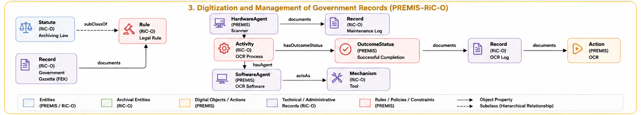
This scenario describes how government documents are digitized and managed in accordance with the PREMIS and RiC-O standards, with an emphasis on OCR processing. Initially, the archival record, known as the Government Gazette (FEK), records a rule of the Legal Rule type. The rule belongs to a broader category, Archiving Law, which is the legal framework that defines how we manage records. Next, an activity is performed, the OCR Process, which involves the digital processing of the document through optical character recognition. This activity is linked to a Software Agent, that is, an OCR program, which runs and executes the process.This specific software also functions as a Tool-type Mechanism, which is the technical means for implementing the entire activity. At the same time, a Hardware Agent is used—specifically a scanner—which records data in another file titled Maintenance Log. There, it stores technical information regarding the scanner’s operation. Upon completion of the process, an Outcome Status of the type “Successful Completion” is generated, indicating that the processing was successfully completed. This result is recorded in a file titled “OCR Log.” Finally, the OCR Log documents the OCR operation, that is, the character recognition process itself that was performed.

Conclusion – Research Results - Future Directions

Conclusions
This thesis examined whether the Records in Contexts (RiC-CM) conceptual model can be extended to meet the needs of digital preservation. Digital collections are constantly growing, while information environments are becoming increasingly complex. This means that models are needed that are not limited to description alone but also encompass the technical, procedural, and organizational aspects of preservation. Furthermore, a systematic analysis of the RiC-CM and PREMIS models was conducted, as RiC-CM offers a robust framework for representing archival relationships and contexts, but does not adequately cover fundamental concepts of digital preservation such as fixity, dependencies, preservation actions, and storage conditions. On the other hand, PREMIS provides a detailed and practically oriented model for managing preservation metadata, without, however, fully covering the archival context. The mapping of the two models revealed possible correspondences and significant conceptual differences. Entities such as Agent and Identifier align immediately, while others require a semantic approach. At the same time, concepts such as Fixity, Dependency, and StorageLocation clearly revealed conceptual gaps in RiC-CM, highlighting the need to extend the model. Based on these findings, I proposed an extension of RiC-CM that allows for the integration of digital preservation concepts without altering its basic structure and philosophy. The approach relies on introducing new relationships and leveraging existing entities to enable the representation of critical preservation information. The application scenarios presented support this proposal. Through examples such as the digitization of photographs, video conversion, and document processing via OCR, it appears that the extended model meets the basic requirements of digital preservation, namely authenticity, integrity, traceability, and long-term accessibility.

Research Results
The main findings of this study are as follows. First, I identified all the major conceptual gaps in RiC-CM, particularly regarding digital preservation. Next, a systematic mapping was performed between PREMIS and RiC-O, identifying both cases where the two models align directly and those where there is a semantic correlation or a complete lack of mapping. At the same time, a conceptual extension framework was proposed for RiC-CM to enable the integration of preservation metadata. Finally, it was demonstrated how archival description can be combined with digital preservation into a unified model.

Future Directions
Although this work makes a significant contribution, there are still areas that require further research. Some future directions include the full implementation of the extension in ontology form (i.e., the conversion of the RiC-O extension to OWL). Additionally, automated mapping mechanisms between PREMIS and RiC-O need to be developed. Another key step is to apply the model to real-world repositories and information systems to demonstrate its practical value. At the same time, it is worth examining how the model can be integrated with other standards such as CIDOC CRM and OAIS.

References

[AHG20] | Allemang Dean, Hendler Jim, Gandon Fabien (2020). Semantic Web for the Working Ontologist : Effective Modeling for Linked Data, RDFS, and OWL  (3rd ed.). https://doi.org/10.1145/3382097
[AGH+25] | Antoniou Grigoris, Groth Paul, Harmelen van Frank, Hoekstra Rinke (2025). A Semantic Web Primer (3rd ed.). MIT Press.
[BHL01] | Berners-Lee, Tim, Hendler, James, & Lassila, Ora (2001). “The Semantic Web.” Scientific American, 284(5), 34–43. https://jmvidal.cse.sc.edu/library/berners-lee01a.pdf
[DGP16] | Dappert Angela, Guenther Squire Rebecca, Peyrard Sebastien (2016). Digital Preservation Metadata for Practitioners: Implementing PREMIS. Springer. https://doi.org/10.1007/978-3-319-43763-7
[DOE03] | Doerr Martin (2003) The CIDOC Conceptual Reference Module: An Ontological Approach to Semantic Interoperability of Metadata, 24(3), 75-92. https://doi.org/10.1609/aimag.v24i3.1720
[CM17] | Corrado M. Edward, & Moulaison Sandy Heather (2017). Digital Preservation for Libraries, Archives, and Museums. https://doi.org/10.5040/9798216405436
[GRU93] | Gruber R. Thomas (1993). “A Translation Approach to Portable Ontology Specifications.”Knowledge Acquisition, 5(2), 199–220. https://doi.org/10.1006/knac.1993.1008
[HKR09] | Hitzler Pascal, Krotzsch Markus, Rudolph Sebastian (2009). Foundations of Semantic Web Technologies. CRC Press. https://doi.org/10.1201/9781420090512
[DAN24] | Dancy Richard (2024). Waiting for RiC: The Release of Records in Contexts, version 1.0. Archivaria, 98, 166–191. https://archivaria.ca/index.php/archivaria/article/view/13997
[CVP+15] | Coppens Sam, Verborgh, Peyrard Sebastien, Ford Kevin, Creighton Tom, Guenther Rebecca, Mannenes Erik, Walle van de Rik (2015). “PREMIS OWL: A semantic long-term preservation model.” https://doi.org/10.1007/s00799-014-0136-9
[DFH11] | Domingue John, Fensel Dieter, Hendler H. James (2011). Handbook of Semantic Web Technologies. Springer.  https://doi.org/10.1007/978-3-540-92913-0
[ICA23] | International Council of Archives .(2023). Records in Contexts – Conceptual Model (RiC-CM), Version 1.0. International Council on Archives. https://www.ica.org/app/uploads/2023/12/RiC-CM-1.0.pdf
[ICA23] | International Council of Archives .(2023). Records in Contexts – Ontology (RiC-O), Version 1.0. International Council on Archives. https://github.com/ICA-EGAD/RiC-O
[ICA21] | International Council of Archives .(2021). Records in Contexts – Conceptual Model (RiC-CM),Consultation Draft v0.2. International Council on Archives. https://www.ica.org/app/uploads/2023/12/ric-cm-02_july2021_0.pdf
[LAV14] | Lavoie Brian .(2014). The Open Archival Information System (OAIS) Reference Model: Introductory Guide, ( 2nd ed.) http://dx.doi.org/10.7207/twr14-02
[LPPS17] | Lianes – Padron Dunia, Pastor – Sanchez, Juan Antonio (2017). “Records in contexts: the road of archives to semantic interoperability", Program, Vol. 51 Issue: 4, pp.387-405, https://doi.org/10.1108/PROG-03-2017-0021
[MIL17] | Millar A. Laura (2017) Archives Principles And Practices. (2nd ed.). Facet Publishing. https://www.slideshare.net/slideshow/archives-principles-and-practices-2nd-edition-edition-laura-a-millar/281728792#6
[NISO17] | National Information Standards Organisation (2017). Understanding Metadata : What is metadata, and what is it for? https://www.niso.org/publications/understanding-metadata-2017
[PEC15] | PREMIS Editorial Committee .(2015). PREMIS Data Dictionary for Preservation Metadata Version 3.0. Library of Congress. https://www.loc.gov/standards/premis/v3/premis-3-0-final.pdf
[OLB24] | Oliveira de Cardoso Caliel, Low Marks Marieta, Barros Bragato Henrique Thiago (2024). “Knowledge Organization Possibilities for Archives: Comparative Semantic Analysis Between CIDOC-CRM and RiC-CM.” Advances in KnowledgeOrganization, 51(5), 362-370. https://doi.org/10.5771/0943-7444-2024-5-362
[VGC+15] | Verdonck Michael, Gailly Frederik, Cesare de Sergio, Poels Geert (2015). Ontology-driven conceptual modeling: A systematic literature mapping and review. Applied Ontology, 10(3–4), 197–227. https://doi.org/10.3233/AO-15015
[KWS+99] | Kim Won, Wand Yair, Storey C. Veda, Weber Ron (1999). An ontological analysis of the relationship construct in Conceptual Modeling. ACM Transactions on Database Systems, 24(4), 494–528. https://doi.org/10.1145/331983.331989
[W3C12] | W3C. (2012). OWL 2 Web Ontology Language Overview. W3C Recommendation. https://www.w3.org/TR/owl2-overview/
[W3C14a] | W3C. (2014). RDF 1.1 Primer. W3C Interest Group Note. https://www.w3.org/TR/rdf11-primer/
[W3C14b] | W3C. (2014). RDF Schema 1.1 Specification. W3C Recommendation. https://www.w3.org/TR/rdf-schema/

https://www.loc.gov/standards/premis/schemas.html
https://www.loc.gov/standards/premis/ontology/index.html

